Responsible Procurement Policy

This document sets out the policy for clearly defining the responsible approach needed when carrying out any procurement activities in the organisation.

Organisation(s): FX Plus
Falmouth University

Applies to: This policy and the procedures involved are applicable to all staff employed by Falmouth Exeter Plus and Falmouth University.

Required Consultees: FXP Procurement, FXP Sustainability team

Approved by: Managing Director FX Plus, Director of Business Services Falmouth University.

Date approved: March 2022

Review date: March 2024

Responsible Procurement Policy.

- Purpose

  - The Falmouth Exeter Plus procurement team are committed to embedding a responsible approach into all aspects of the procurement process and our wider activities. As an organisation we understand that the procurement of goods, services and works has a significant impact on the environment, society, and the economy.
- Scope

  - This policy will apply to all staff of Falmouth Exeter Plus and all University subsidiaries to ensure everyone consistently and uniformly adopts the triple bottom line approach into all procurement decisions and to encourage supplier behaviour to help us achieve our environmental and climate emergency goals.

- Related information

  - Falmouth Exeter Plus Responsible Procurement Share-Point Page; https://falmouthac.sharepoint.com/sites/FXPlusCO/SitePages/Sustainable-Procurement.aspx
Falmouth Exeter Plus Sustainability Share- Point Page:
https://falmouthac.sharepoint.com/sites/FXPlusSus
Modern Slavery Act 2015:
https://www.legislation.gov.uk/ukpga/2015/30/contents/enacted
The Late Payment of Commercial Debts Regulations 2015;
https://www.legislation.gov.uk/uksi/2013/395/contents/made
Equality Act 2015;
https://www.legislation.gov.uk/ukpga/2010/15/contents
Bribery Act 2010;
https://www.legislation.gov.uk/ukpga/2010/23/contents
Net Positives Futures;
https://supplierengagementhe.net-positive.org

- Policy

  - The Responsible Procurement delivery plan has committed to record progress to the following core principles;

    - Procurement decisions will balance People, Planet and Profits (social, environmental, and economic).

    - Tender specifications will clearly demonstrate the importance of our commitment to the integration of the triple bottom line approach throughout the entire procurement process.

    - Contract management will include key performance indicators and incentives which reflect the environmental and social performance of the requirement.

    - We will support and encourage SME’s and local suppliers to tender for our contracts

    - We will engage with all suppliers to encourage the adoption of environmental and social good practice and build awareness and an active response to slavery and human trafficking.

    - Fair trade or equivalent shall be considered for all catering and hospitality product categories.

- Aims and Objectives (2021-2024).

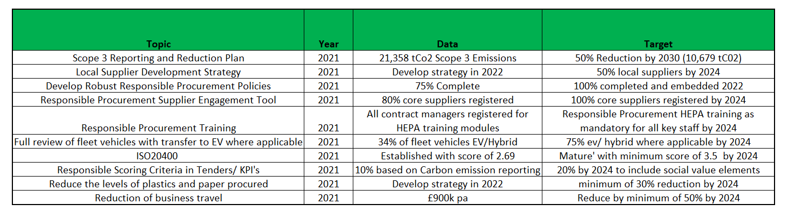

- Training

  - It is important that all staff have access to appropriate training and knowledge development to enable the organisation to achieve our social, environmental and climate emergency goals.

  - All staff members will have access to the HEPA sustainability training modules as well as a number of help- guides on the procurement team’s share-point pages. Regular face to face training with the procurement team will also be available throughout the academic year.

- Responsible Bought Goods and Services

  - Responsible procurement considerations will form part of everyday practice and will be incorporated into service specifications, service level agreements, key performance indicators, tender evaluations, contract reviews and category management.

  - All members of staff will be encouraged to adopt and comply with the responsible procurement checklist to determine needs for items to be procured, question the need for new items, the quantity purchased and to consider alternative solutions, such as re-use, lease, and sharing resources so that specifications are functional and not over-specified.

  - Specific environmental and sustainability questions will be included in all tender documents and evaluated against a minimum weighting of 10%.

  - The procurement and sustainability teams will work collaboratively to focus on high-risk carbon emission categories, which include;

- Business Travel
- Construction
- IT Services
- Food and Catering

- Supplier Management

  - The procurement team will proactively engage with the supply chain to ensure we are open, fair, and transparent on what our economic and climate emergency expectations are.

  - All suppliers will be required to register on the supplier engagement tool (Net Positives Future) which will help improve their sustainability and corporate responsibilities.

  - As part of the tender process, all suppliers will be required to complete a Sustainability questionnaire and provide information on how they plan to reduce their social, carbon and environmental footprint over the duration of the contract. This will be measured as part of the quarterly review meetings

  - As part of the quarterly review meetings, suppliers will be provided with a supplier performance report, detailing their progress on all key performance indicators (including sustainability and carbon reduction)

  - Opportunities to learn from each other will be built into all engagements with the suppliers, i.e., pre-tender market testing, quarterly review meetings, supplier questionnaires, supplier days and procurement training workshops.

  - The procurement team will support all local based suppliers and SME’s in simplifying processes and encouraging them to bid for projects.

Chris Jones
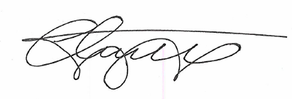
Head of Procurement
March 2022

