Connecting a Mac to FXNET_Secure

Problem:
Connecting to FXNET_Secure.

Problem Solution:
Follow the How To guide below.

How To:

1 - At the top right-hand corner of the desktop click on the Wireless icon and then click on FXNET_Secure. When prompted enter your university username and password.
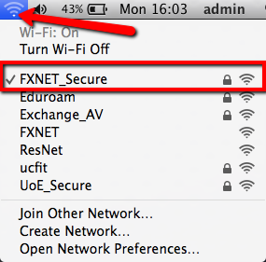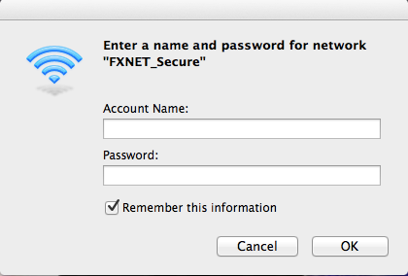

2 - Click Continue on the next window.
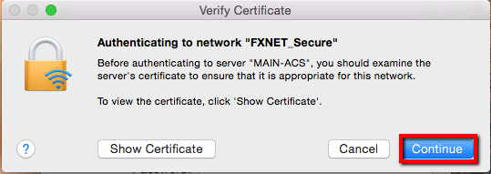

3 - If your MAC belongs to the university you will need the admin account to update the certificate trust settings. Ring the I.T. Service desk on 3822 or email servicedesk@fxplus.ac.uk to get this done but you can click cancel in the meantime to get access onto FXNET_Secure. However, you will be prompted to update the certificate trust settings next time you connect to FXNET_Secure. If the MAC belongs to you enter the admin username and password to update settings.
University Mac Personal Mac
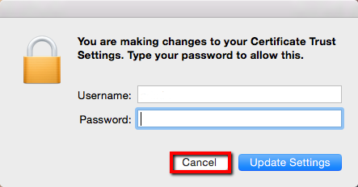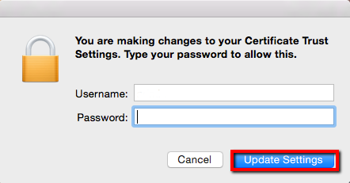
You will now be connected to FXNET_Secure.

