Connecting an Android device to FXNET_Secure

Problem:
Connecting to FXNET_Secure.

Problem Solution:
Follow the How To guide below.

How To:

1 - First select the Apps draw then settings and select Wi-Fi, FXNET Secure.

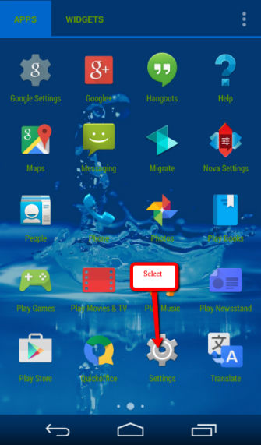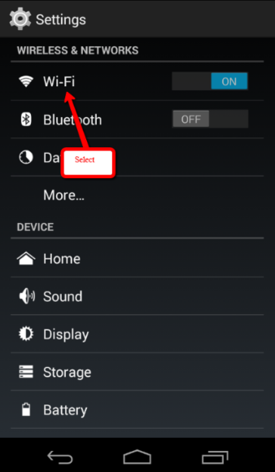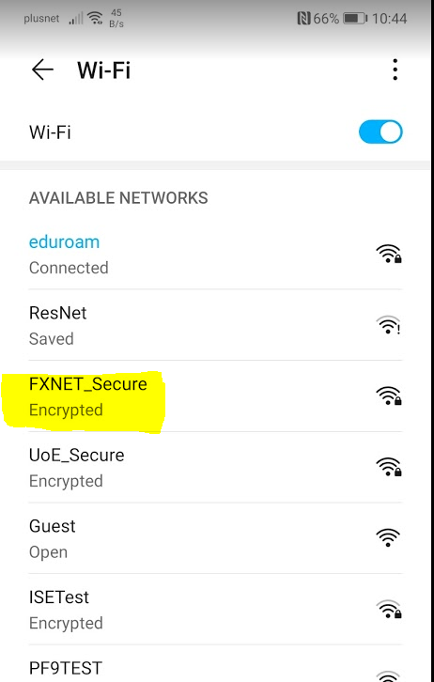

2- You will now be prompted to enter in the security details. First select PEAP as the EAP method then MSCHAPV2 in the Phase 2 authentication option. Put in your university username and password, ignore Anonymous identity, then click on connect. IN the Wi-Fi menu you will then see you are connected.

