**Management Plan 2018/19**

**Tremough Gardens**



**Content**

1. **Background 3-11**
2. **SMART Objectives and indicators 11-14**
3. **Green Flag criteria 15-16**
4. **Risk Assessment 16-25**
5. **Buildings and landscape 26-27**
6. **Environmental Sustainability 28-32**
7. **Transport and Travel 32-34**
8. **Conservation and Heritage 34-35**
9. **History Tremough Gardens 36**

**10. Community involvement 37-38**

**11. Facilities 39-40**

**12. Marketing 41-45**

**13. Actions 46-64**

**14. Season schedule 65-66**

1. **Background**

**Vision**

We want to protect value, enhance and respect biodiversity (the variety of life on earth) and the ecosystem services it provides for the Penryn and Falmouth campuses. We want to maintain the campuses’ grounds in an environmentally sensitive way, enhancing natural habitats and biodiversity on the estates.

**The why**

The Penryn Universities Campus for Falmouth and Exeter has a turnover of around 5500 (2016) students. However, the Universities are in the midst of a long term, multi-million pound development plan to accommodate growth in student numbers, expansion of degree course provision and increased research activity.

**From 2015/16 to 2020 numbers are projected to grow by 2326 across both**

**campuses and by 1800 at the Penryn Campus**

|  |  |  |  |  |  |  |
| --- | --- | --- | --- | --- | --- | --- |
| **2015/16** | **2016/17** |  | **2017/18** |  | **2018/19** | **2019/20** |
| **Funding Council**  **Confirmed\*\*** | **Target** |  | **Target** |  | **Target** | **Target** |
| Falmouth  University:  Penryn  Campus | 2,872 | 3,466 |  | 3,866 | 4,140 | 4,282 |
| Falmouth  University:  Falmouth  Campus | 1,477 | 1,912 |  | 1,919 | 1,956 | 1,985 |
| **Falmouth**  **University**  **Total on campus** | **4,349** | **5,378** |  | **5,785** | **6,096** | **6,267** |
| **University of Exeter:**  **Penryn**  **Campus\*** | **1,983** | **2,101** |  | **2,178** | **2,295** | **2,361** |
| **Combined** | **6,332** | **7,479** |  | **7,963** | **8,391** | **8,628** |

|  |  |  |  |  |  |
| --- | --- | --- | --- | --- | --- |
| **Both campuses** | | | | | |
| **Combined**  **Penryn**  **Campus** | **4,855** | **5,567** | **6,044** | **6,435** | **6,600** |

Numbers exclude any net increase for exchange students and distance learning students

*Excludes Truro Campus students

**These are the Funding Council (HEFCE) confirmed numbers, excluding w ithdrawals but including late entrants

The impression that the campuses give to its students and visitors is extremely important. Annual surveys are undertaken of student and visitor opinions in order that the grounds and elements connected to it can be assessed and, where necessary, improved.

The Penryn campus is surrounded by over 100 acres of countryside and farmland, adding to the appeal of a small-town, rural feel. As well as the aesthetic quality of a “green” campus, this area is home to a number of important wildlife species needing conservation. However, development is essential for an institution that plans to grow and expand. There are areas of great biodiversity potential but many of the areas earmarked for development could negatively impact the biodiversity of the campus and its protected habitats. Hence the need for a 5 year Biodiversity Management, action plan, communication and marketing plan and a BAP (Biodiversity Action Plan).

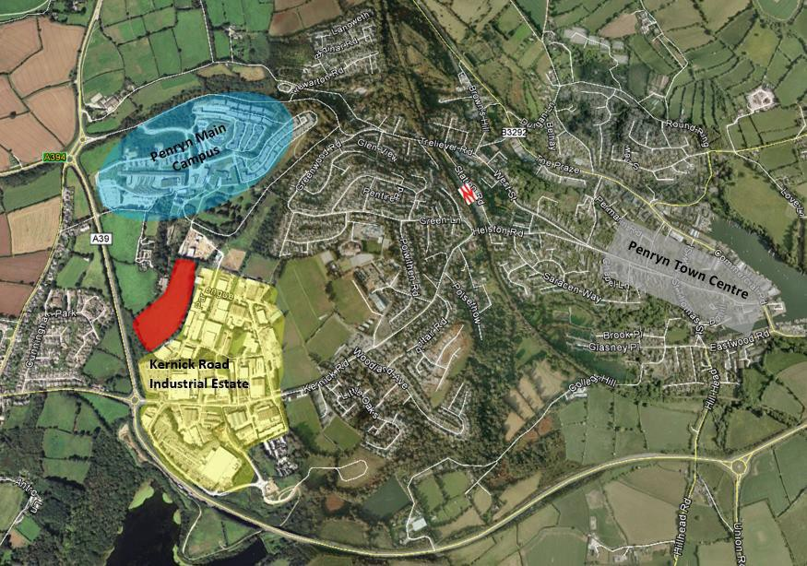Penryn Campus

**Maps of the Penryn campus**

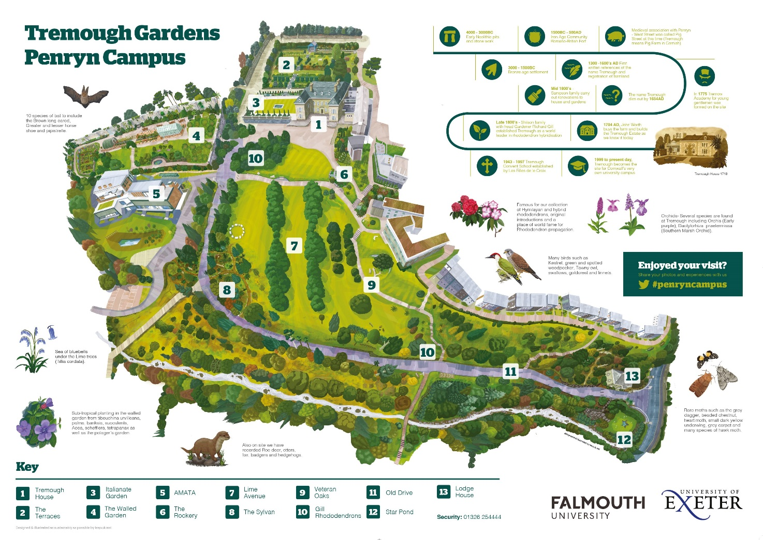

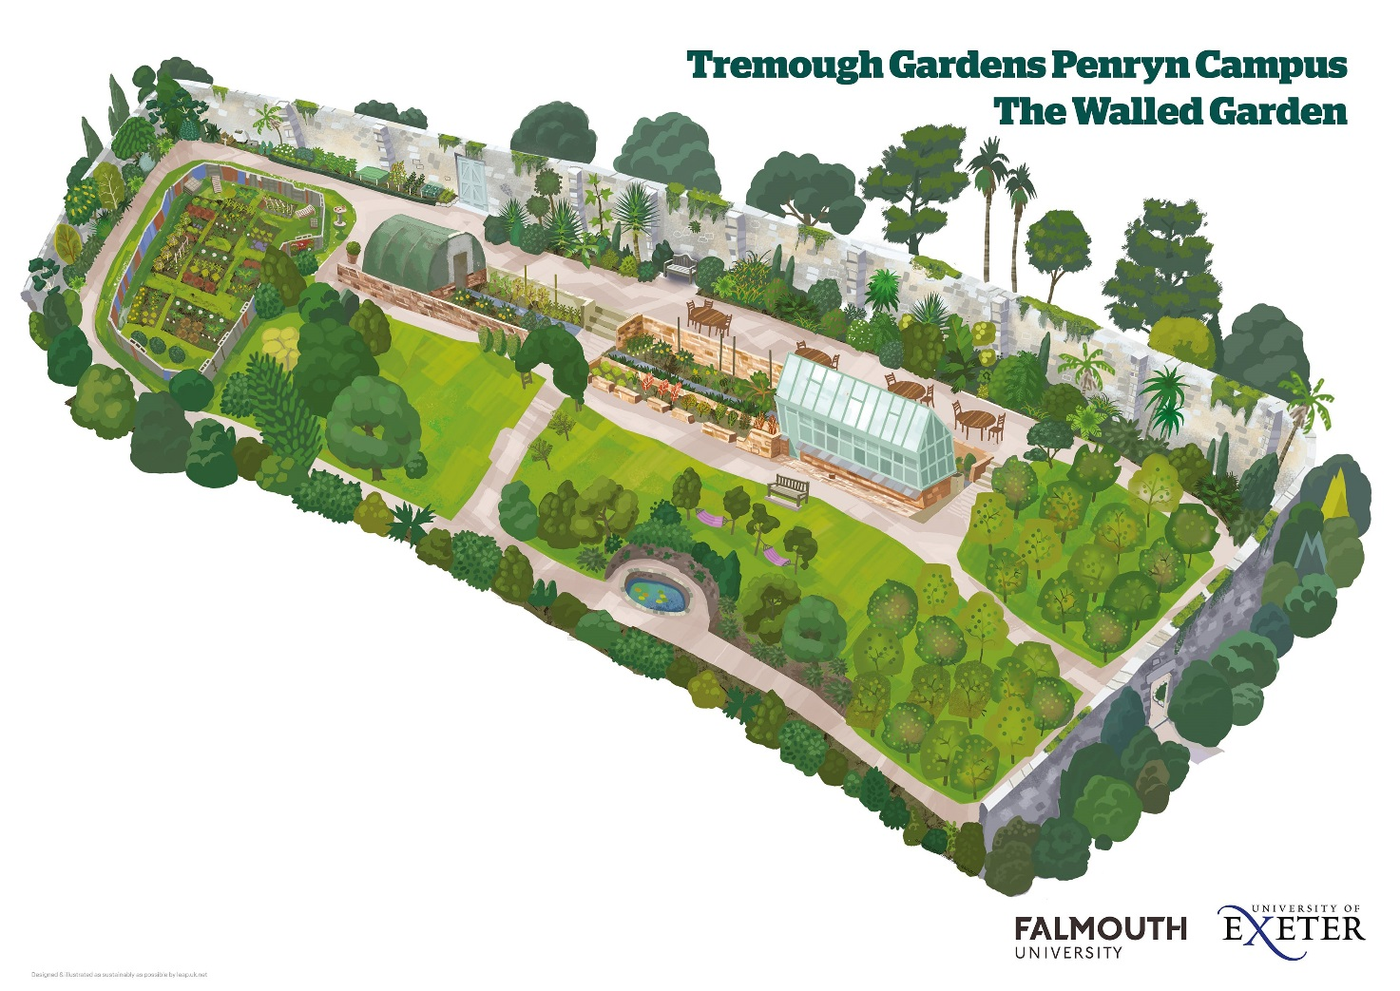

Site maps Penryn campus

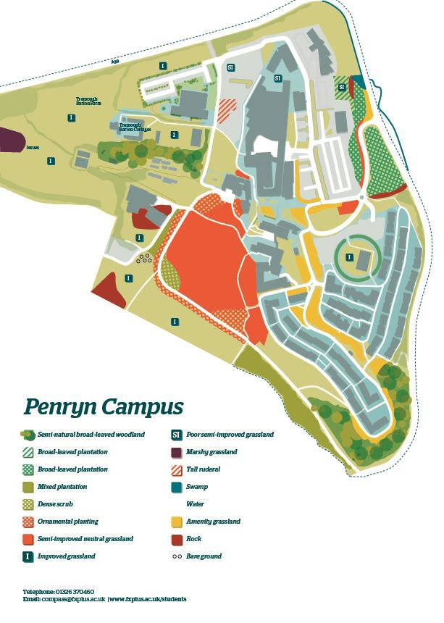

Habitat map 2016

**The Gardeners at Tremough**

**Toby Nenning**, Head Gardener-20 years gardening, over 10 on the estate. HND horticulture. Love the outdoors and Cornwall.

**Paul Watson**, Assistant Head Gardener, Former welder, studied Horticulture in 1998, skilled horticulturalist at Eden project from 1999-2008 then came to work here. “man cannot live without plants, plants thrive without man”.

**Paul Bontoft,** studied forestry in Hampshire, qualified as tree surgeon. Worked as arborist for 20 years came to FXPlus 3 years ago.

**Matt Lewis** 40 years horticultural experience, 18 years of that abroad in four different countries.

**Alasdair Garnett**, RHS level 2 and here for last 5 years. Interested in conservation and enjoy the wildlife on campus. Particularly enjoy the walled gardens ornamental and edible plants.

**Dave Roberts**, started here on work experience (job centre) four years ago and loved it. After showing a strong aptitude for gardening he was offered a full time position.

**The Business case and how we can benefit from Biodiversity**

As mentioned before, loss of biodiversity due to increased development of the sites, needs to be minimized by specific designation of the various areas. Success of planning applications can be assisted by incorporating ways of protecting and enhancing biodiversity. Biodiversity is also an important aspect in environmental reporting and gaining official accreditation. For example Green Flag, Green Gown, EcoCampus, ISO14001 or BS8555 (International environmental standards) are reputable awards and accreditation. It is also important to note that Penryn campuses have been chosen by students (2015/16) for its environment and it is important to build on this, for future generation to enjoy the sites.

Furthermore, students, staff, visitors and the wider community will benefit from maintaining the unique feel of the campus:

•  **reputation and green image**; good environmental practice enhances the reputation of the institutions as biodiversity projects are often very visual. Protecting and enhancing biodiversity is important if the aim is to be awarded with sustainability construction standards such as BREEAM (building sustainability assessment). This standard contains a wide variety of biodiversity criteria that can contribute to the level of award that you can expect to achieve and promote long term biodiversity management in new developments.

•  **events**; already several events have found place such as apple/cider days and

the open day for the community. More are planned for 2018 and beyond.

•  **trails**; in the planning are an edible trail, running and walking trails.

•  **photography and arts**; as the photography faculty (Falmouth University) is situated on the Penryn campus it offers a great opportunity for the students to take photos, film and other art and performance purposes.

•  **science;** renewables/ bioscience/ecology

•  **carbon**; the relation between biodiversity and carbon is complex and

interdependent as impact can occur outside the area of management. However, it is important to raise awareness about carbon through biodiversity.

•  **build stronger relationship with the wider communities**; involving staff, students and the wider community will give them a sense of ownership and generates a feel good factor. It also shows that it is actively investing in local environmental involvement.

• **green gym**; many studies have shown that green spaces can help improve physical and psychological health. A green campus enhances the work and study environment and provide opportunities for exercise and recreation. With the new gym in place it offers opportunity to develop green gym classes in the gardens, i.e. yoga in the Italian gardens and practical conversation work burns calories too!

•  **save money by**;

-creating living walls

-green/brown roofs

-leaving grass unmown for part of the year;

-using native species, particularly that are chosen specifically for the local conditions (e.g. micro-climate, soil type, shade, sun), that are more likely to thrive with less management or watering;

-reducing or eliminating chemical use;

-using less water on lawns;

-making own mulch and compost by shredding tree and shrub waste

-copicing; firewood, fence panels, charcoal etc.

-sequestration; by planting trees and creating green areas that have permanent vegetation helps reduce the amount of carbon dioxide (CO2) in the atmosphere. CO2 is the primary greenhouse gas that causes climate change. Vegetation can store it through carbon sequestration, at least in the short term.

-flood reduction and water conservation; green spaces act as a ‘sink’ for water.

This means that they reduce drainage needs and conserve water by absorbing rainfall, rather than allowing it to run off into drains. Many institutions are also

benefiting from Sustainable Drainage Systems (SUDS), which effectively collect and treat rainwater and potentially create wildlife habitats.



Green roofs campus

**Legal compliance**

While legal compliance is not the primary driver for the development of the biodiversity management plan, it is, nevertheless an important consideration. The Universities’ legal obligation to protect biodiversity is set out in the Natural Environment and Rural Communities Act (NERC), which came into force on 1 October 2006. Section

40 requires all public bodies ‘in exercising its functions, to have regard, so far as is

consistent with the proper exercise of those functions, to the purpose of conserving

biodiversity’.

**Awards**



Daffodil Hermoor

The Grounds Team for the Falmouth and Penryn university campuses took away a beautiful bunch of firsts at the weekend in the 106th (2016) annual Falmouth Spring Flower Show. The team from Falmouth Exeter Plus (FX Plus), won 14 first place awards including winning the highly coveted Chamber of Commerce Silver Cup for the best shrubs and flowering shrubs, for the first time. Their Daffodil 'Hermoor' not only won First Prize but also Best in Section and a Daffodil Society diploma. Apart from these awards, they also won the following:

•  2 Gold Green Impact awards

•  Falmouth Uni Best Team

•  Falmouth flower show Chamber of commerce challenge cup and the latest is the Green Flag Award (2017). 

1. **SMART Objectives and indicators**

The management of biodiversity is undertaken with the following SMART (Specific, Measurable, Attainable, Relevant and Timely) -objectives in mind. The Action plan,

see below, has been prepared in conjunction with the objectives.

**Objectives Indicators**

1. **as far as is practicable, to conserve and enhance existing valuable habitats and to create new habitats across the Penryn campus**

•  changes in habitat map

•  all tree planting must be

100% native species (designated conservation areas)

•  BAP (Biodiversity Action Plan) integrated in the Action plan

•  Bioblitz (annual wildlife

survey)

•  decrease of the use of residual pesticides and increase the use of non- residual and biological/non- chemical control techniques invasive species

**2. to encourage staff to question the need for new items, the quantity**

**purchased, and to consider alternative**

•  reuse of wood

•  reuse of machinery

•  rental resources

b

|  |  |
| --- | --- |
| **solutions such as reuse, rental and**  **sharing resources so that specifications are functional and not over-specified**  **3.to always consider ecological impacts and opportunities for ecological enhancement of any building refurbishments and any new building designs or construction activities as well as procurement**  **4.to seek to work in partnership with environmental groups and outside organisations, to share knowledge and resources**  **5.to seek funding and grants to facilitate biodiversity aims and principles**  **6.to involve staff, students and the local community in biodiversity issues through promoting and identifying opportunities for all to engage in volunteering, educational activity and events**  **7.to use biodiversity to promote healthy living and wellbeing through improved outdoor amenity areas**  **8.to comply with any relevant UK**  **legislation regarding biodiversity**  **9.to implement green waste management including litter** | •  sharing resources  •  purchases of local plants  •  sale of plants (events) |
| •  increase in green/brown  roofs/living walls  •  impact of the hard landscaping review Gillespie strategy 2020 report |
| •  work with WWF  •  Bioblitz survey  •  Collaboration projects with  EcoSoc  •  active other partnerships |
| •  amount of money raised  through funding and grants |
| •  number events  •  number volunteers  •  facebook page hits/subscribers |
| •  facebook page  hits/subscribers  •  number of green gym activities  •  number of arts and  performances |
| •  annual review |
| •  amount of compostable  waste  •  usage of woody waste around campus  •  burning of non- compostable or infected waste  •  amount of litter collected |

**10. to raise awareness and hold events for students, staff and the local**

**community**

•  innovative waste management projects, i.e. growing trees in compost pits

•  number of events

•  number of publications

**BAP (Biodiversity Action Plan) and Biodiversity Policy**

As part of the Green Consultant programme, a team from the University of Exeter has undertaken work to create a Biodiversity Action Plan for the Penryn campus of the University of Exeter. This report aimed to analyse the species present within and the immediate surrounding area of Penryn Campus, and suggested mitigation on the effects of habitat loss that comes with the pressures of expansion and development.

Biodiversity Policy-click [here.](http://www.fxplus.ac.uk/documents/fx-plus-biodiversity-policy)

1. **Green Flag criteria**
2. Healthy, Safe and Secure

Falmouth Exeter Plus is committed to providing a healthy and safe working environment for all its employees, students, contractors and visitors who may be affected by its activities on the Penryn Campus. This commitment is expressed in Falmouth Exeter Plus’s Health & Safety Policy Statement.

The Health & Safety [web page](http://www.fxplus.ac.uk/staff/health-safety) is designed to provide information and guidance on all matters of health and safety to enable Falmouth Exeter Plus employees to fulfill their legal and moral responsibilities in relation to the health, safety and welfare of those who may be affected by their undertaking.

Grounds staff operate throughout the campus during daylight hours. They will assist students and visitors as much as possible, reporting any incidents that may occur on the grounds via Security.

Staff, students and visitors are also considered in all aspects of the work undertaken by grounds staff. In liaison with the university’s health and safety advisors grounds staff have developed guidance, risk assessments and methodologies to ensure they protect themselves and others while working on the grounds.

The grounds are open to the public throughout the year, 24 hours per day. The overall ethos is for staff to be highly visible and diligent, attempting to promote sensible use and care of the grounds in a sympathetic manner that creates an impression that the grounds are safe and secure.

The grounds are used by (dog) walkers, joggers and provide access to a range of sports, including football, rugby, tennis and other outdoor sports. Students, individuals, clubs and associations locally make use of the excellent facilities available.

**4**. **Risk assessment**



**Falmouth Exeter Plus Risk Assessment Form**

**Department**

Grounds

**Location**

Penryn Campus

**Date of assessment**

6/1/17

**Assessor Operation** Gardening **Serial Number**

**(Dept/No)**

**Date to be**

**reviewed** Completed by: T Nenning

**Date to be**

**Reviewed**

Completed by:

**Date to be**

**Reviewed**

Completed by:

**harmed and how? Control Measures in place**

**Hazard Who might be**

**Risk with controls in place**

**Rating What further action is necessary?**

**Risk**

**Action by whom and when?**

**Done**

Work

Equipment

Staff, students or visitors could be harmed by various work equipment i.e.mowers,strimmers, chain saws, vehicles etc..

**S L S x L L/M/H**

Before use checks in place 2 2 4 **L** Safe system of w ork required for TN

various w ork equipment:

Chainsaws:

[http://w w w.hse.gov.uk/pubns/in dg317.pdf](http://www.hse.gov.uk/pubns/indg317.pdf)

[http://w w w.hse.gov.uk/pubns/af ag308.pdf](http://www.hse.gov.uk/pubns/afag308.pdf)

Strimmers

Hedge cutters



|  |  |  |  |  |  |  |  |  |  |
| --- | --- | --- | --- | --- | --- | --- | --- | --- | --- |
|  |  |  |  |  |  |  | Chipper:  [http://w w w.hse.gov.uk/pubns/af ag604.pdf](http://www.hse.gov.uk/pubns/afag604.pdf)  Rotavator Leaf Blowers Ride on mowers  ATV:  [http://w w w.hse.gov.uk/pubns/ai s33.pdf](http://www.hse.gov.uk/pubns/ais33.pdf)  Tractor : [http://w w w.hse.gov.uk/pubns/in dg185.pdf](http://www.hse.gov.uk/pubns/indg185.pdf)  Abrasive wheel Generators Drills  NPTC Standard Training required  Investigate if all equipment needs to be on insurance register. (Paul Hirst) |  |  |
| Manual  Handling | Staff & volunteers risk of  musculoskeletal injuries resulting | Staff have received manual handling training | 1 | 2 | 3 | **L** | Refresher training required  training matrix w ith Staff development. | TN |  |



|  |  |  |  |  |  |  |  |  |  |
| --- | --- | --- | --- | --- | --- | --- | --- | --- | --- |
|  | from lifting and carrying heavy or awkward  objects, i.e. loading / unloading trailers etc | Tasks that involve lifting w ill be eliminated w henever possible by the use of: decanting items to reduce the w eight  Good manual handling techniques will be used for all lifting tasks  Volunteers receive induction training following HSE guidance:  [http://w w w.hse.gov.uk/pubns/indg143.pdf](http://www.hse.gov.uk/pubns/indg143.pdf) |  |  |  |  | TN to produce department  training matrix |  |  |
| Slips, trips & Falls | Staff, students, contractors and visitors may suffer bruising, cuts or fractures if they were to trip over or fall. | During Autumn & W inter months leaf  blowers used to clear leaves and debris.  Clean & tidy workspace after any work activity i.e. law n mowing, chipping, tractors etc.  Snow & Policy in place  Signage placed out | 2 | 2 | 4 | **L** | Look into purchasing new signage  & barriers etc. | TN |  |
| Working at  height | Staff, risk of being  injured w hilst working on ladders MEW P, Tower scaffold | Avoid w orking at height w here reasonable  Work behind barriers or obstacles to prevent falls  Hareness training for roof w ork & steep banks | 2 | 2 | 4 | **L** | Working at height refresher due  April 2019  Ladder safety training, ladders to be safety checked: HSE  Guidance  :[http://w w w .hse.gov.uk/pubns/i ndg455.pdf](http://www.hse.gov.uk/pubns/indg455.pdf) | TN |  |



|  |  |  |  |  |  |  |  |  |  |
| --- | --- | --- | --- | --- | --- | --- | --- | --- | --- |
|  |  | Working at height training carried out April  2016  MEW P Training carried out |  |  |  |  | Further IPAF Training required  PASMA Training  Before use checks on equipment |  |  |
| Chemicals / Pesticides /  Biological  Hazards | Staff, risk of chemicals being  absorbed, or injected through the skin, inhalation or ingestion. Contact w ith biological hazards i.e. needles, faeces, rats urine etc | Chemical in locked cabinet  Only qualified staff to use pesticides/herbicides (PA1 &6)  PPE used  Needle stick guidance | 1 | 1 | 2 | **L** | Managerial PPE Checks to be  carried out  COSHH Training required  Bring Needle stick guidance to the attention of staff | TN |  |
| Fire | Risk to staff, visitors w ho could  be injured if trapped w ithin the building, through smoke inhalation and burns | Petrol locked in petrol cabinets, in locked  room  Fire procedures in place  Instruction notices in place  Fire extinguishers & maintained Fire risk assessment in place Fire drills  Appliances turned off at the end of the day | 2 | 1 | 3 | **L** | Continuous monitoring | TN |  |



|  |  |  |  |  |  |  |  |  |  |
| --- | --- | --- | --- | --- | --- | --- | --- | --- | --- |
| Noise | Staff, may be subjected to noise  using w ork equipment i.e. strimmers, mowers etc and suffer from hearing loss, tinnitus etc | Ear defence w orn  Selection of low noise equipment w here reasonable  Equipment maintained by user | 1 | 1 | 2 | **L** | Health Surveillance organised for early 2017w ith University Exeter.  Ensure Ear protection is suitable for given tasks (PPE Matrix)  PPE checks | TN |  |
| Whole body  vibration | Staff may become  injured w hilst using poorly maintained or selected w ork equipment, i.e. chain saw s, mow ers etc | Selection of correct equipment w here  reasonable, and maintained. | 1 | 1 | 2 | **L** | Health Surveillance organised for  early 2017 w ith Exeter. | TN |  |
| W ater | Staff, students and  visitors risk of drow ning |  |  |  |  |  | Review on w ater features around  Campus |  |  |
| W orkplace  Transport | Staff, students  visitors may become injured w hilst using or around w ork equipment | Staff hold driving licences  Vehicles use on Campus  Amber flashing lights | 1 | 1 | 2 | **L** | Training for Tractors, ATV, ride  on mowers. Maintenance  Driving at w ork Policy | TN |  |
| Personal  Protective Equipment (PPE) | Staff may be  injured w hilst not using PPE correctly | PPE stored in users lockers | 1 | 1 | 2 | **L** | PPE risk assessment required  Instruction / training  Monitored | TN |  |



|  |  |  |  |  |  |  |  |  |  |
| --- | --- | --- | --- | --- | --- | --- | --- | --- | --- |
|  |  |  |  |  |  |  | PPE to be identified on  equipment Safe Systems of work |  |  |
| Lone Working | Staff, may be  injured from using w ork equipment and not be able to summon assistance, whilst using mowers etc | Staff issued w ith Radios  Staff have phones  All w ork betw een 07:30 – 16:00  High risk activities carried out in tw o’s | 1 | 1 | 2 | **L** | To be identified on equipment  Safe Systems of w ork. | TN |  |
| Work  environment /  workplace & welfare provisions | Staff,  uncomfortable working environment due to poor lighting, ventilation, inadequate temperature control excessive noise. Lack of First aid provisions & inadequate protection from the ultraviolet radiation. | Good lighting  Washing facilities including showers  Heating / Drying room  Basic food heating facilities, toaster kettle etc  Lockers for equipment  Soap / Water First aid kits Female sanitation | 1 | 1 | 2 | **L** | Check First Aid kits  Re-view First aid provisions  Re-view housekeeping  Hats and sun cream available | TN |  |
| Display  screen equipment – PC & Laptop use | Muscular skeletal  disorders, pain, discomfort and injury due to over use or incorrect set up. Headache eye fatigue and stress | 2 x computers  Staff guidance: Health & Safety page  Workstation and equipment set up to ensure good posture and to avoid glare and reflections on the screen i.e. use of foot stalls, having the w indow to the side of the user, use of blinds. | 1 | 1 | 2 | **L** | DSE Chairs not suitable, require  replacement.  DSE Assessments required | TN |  |

|  |  |  |  |  |  |  |  |  |  |  |  |  |  |  |
| --- | --- | --- | --- | --- | --- | --- | --- | --- | --- | --- | --- | --- | --- | --- |
|  | |  | Work planned to include regular breaks or change of activity – short, frequent breaks are better than longer, less frequent breaks.  Lighting and temperature suitably controlled.  Eye tests provided for those w ho need them, FX Plus to pay for basic spectacles specific for VDU use (prescribed for the distance at w hich the screen is viewed). | |  | |  |  |  |  | |  |  | |
| Verbal and  physical violence and aggression | | Harm to staff due  to physical & verbal violence. Stress related to the situation | All incidents and concerns (physical and  verbal) are reported to the line manager, security (if appropriate).  Staff briefing/training on recognising challenging/risky situations and diffusing the situation e.g. conflict management / personal skills  If necessary (based on level of risk) avoid lone w orking | | 2 | | 2 | 4 | **L** | Continuously monitor  Investigate panic button on  Radio | | TN |  | |
|  | **Name** | | | **Signature** | | **Department** | | | | | **Date** | | |  |
| Toby Nenning | | |  | | Grounds | | | | | 9/1/2017 | | |
|  | | |  | |  | | | | |  | | |

|  |  |  |  |
| --- | --- | --- | --- |
|  |  |  |  |
|  |  |  |  |

I confirm I have read and understood the risk assessment and am able to work within the control measures. If at any point I a m unable to work within these controls, I will cease work and

inform my supervisor/manager.

Risk assessments need to be approved by the Line Manager prior to implementing. This risk assessment will be reviewed at least annually or as required due to a change in the risk severity or a change in the working procedures. Any changes made will be brought to the attention of all personnel who may be affected by the change.

**Guidance on completing the risk assessment form**

|  |  |  |
| --- | --- | --- |
| **Severity categories** | | |
| 1 | Very minor injury | Causing scratches / abrasion. |
| 2 | Minor injury | Causing sprains, bruises, cuts and lacerations. |
| 3 | Major injury | Causing temporary disability (fractures), burns, lost time accident. |
| 4 | Severe injury | Causing permanent disability (loss of limb, sight or hearing). |
| 5 | Fatality | Causing death to one or more people. |
| **Likelihood categories** | | |
| 1 | Rare | Loss, accident, illness could only occur under freak conditions. The situation is well managed and all reasonable precautions have been taken. |
| 2 | Unlikely | The situation is generally well managed, however occasional lapse could occur. This also applies to situati ons where people are required to behave  safely in order to protect themselves but are well trained. |
| 3 | Possible | Insufficient and substandard controls in place. Accident/incident is unlikely during normal operation, however it may occur i n emergencies or non-  routine conditions (e.g. unsupervised equipment, obstructed walkways, refresher training required). |
| 4 | Likely | Serious failure in management controls. The effects of human behaviour or other factors could cause an accident but is unlike ly without additional  factor (e.g. ladder not secured properly, oil spill on floor, poorly trained personnel). |
| 5 | Almost certain | Absence of any management controls. If conditions remain unchanged there is a 100% certainty that an accident will happen (e.g. lack of edge  protection while working at height, untrained personnel, no safe systems of work). |

Using the formula: Risk Rating = Severity x Likelihood, the risk rating can be calculated and will identify a Low, Medium or High risk.

|  |  |  |  |  |  |
| --- | --- | --- | --- | --- | --- |
| SEVERITY | 1 – Very minor injury | 2 – Minor injury | 3 – Major injury | 4 – Severe injury | 5 – Fatality |
| LIKELIHOOD | 1 – Rare | 2 – Unlikely | 3 – Possible | 4 – Likely | 5 – Almost certain |

|  |  |  |  |  |
| --- | --- | --- | --- | --- |
| RISK RATING | 1 – 5  **Low** | 6 – 11  **Medium** | 12+  **High** | Severity (S) x Likelihood (L) = Risk Rating |

|  |  |
| --- | --- |
| LOW RISK (1 – 5) | May be acceptable, however, review task to see if risk can be reduced further. |
| MEDIUM RISK (6 – 11) | Task should only proceed with appropriate consultation with specialist personnel. Where possible the task should be refined t o take account of the hazards  involved or the risks should be reduced further prior to task commencing. |
| HIGH RISK (12+) | **Task/Process/Operation must not proceed.** It should be refined further and additional control measure put in place to reduce risk i.e. using the  hierarchy of control measures:  eliminate the hazard,  substitute the hazard with a lesser risk, use of engineering controls, Administrative controls.  Personal protective equipment |

1. **Buildings & landscape**



## New buildings

A number of new buildings at the Penryn Campus have opened:

* [Sports Centre](http://www.fxplus.ac.uk/about-us/investing-future/penryn-campus-sports-centre-and-nursery) which includes a 700sqm four-court sports hall, 150sqm fitness studio and a 350sqm gym with up to 90 stations, equipped by Pulse Fitness. This new Sports Centre is available for use by students, staff and the local community.
* Little Wonders [nursery](http://www.fxplus.ac.uk/about-us/investing-future/penryn-campus-sports-centre-and-nursery) for students, staff and parents in the local community caters for 54 children aged 0-5 years in three age-group rooms, each with outdoor play and learning areas.
* The reception is located next to the new shop to enhance the day to day life of students and improve the visitor experience
* We’re working with private sector developers to identify suitable sites for the development of new purpose built student accommodation in Falmouth and Penryn to accommodate approximately 1,250 bed spaces.
* We have secured purpose built university accommodation in Truro for 2017/18 and will continue to encourage students to live in areas outside Falmouth and Penryn. Students living at Treliske Halls in Truro are provided with a Mussel card (worth over £4000) which offers free local transport on selected train, bus and ferry routes.

**Landscape** reports on request.

**Transport and Parking**

We appreciate the additional burden of cars which comes with expansion of the Universities, and actively try to put other measures in place so that students and staff have other options to travel to campus. As numbers grow we will be further subsidising the expansion of the local bus services which benefits students, staff and the local community.

FX Plus is committed to regularly updating the [Green Travel Plan](http://www.fxplus.ac.uk/find/travel-transport/green-travel) for Cornwall Council approval. Included within this is encouragement to minimise car use whilst maximising bus, cycle and pedestrian use for travel to and from the campus. A five year bus contract with First Fal was agreed in September 2014.

Through our Green Travel Plan we have:

* Worked with First Bus to introduce the U3 bus which operates directly between
* the Falmouth Campus and the Penryn Campus
* Reduced bus fares to £1 per journey between Falmouth and Penryn Campuses.
* Night bus to Treliske Hospital
* Supported the Mussel Card
* Promoted collaborative projects with Sustrans on cycling and walking events
* Introduced lower car parking charges at Penryn Campus for lower emission vehicles
* Installed our first Electric Car charging points at the Penryn Campus
* Created 700 cycle parking spaces across both campuses
* Added four Dr Bike cycle checks and cycle tool kit loan
* In partnership with FXU, created a car share portal

Public footpaths are being improved and cycle lanes introduced on routes approaching the Penryn Campus.

**3. Litter:** there is no specific litter policy in place but there are procedures:

•  three times per week the Grounds team undertake litter clearing in the morning

•  dog bins on site

•  currently in the process of training enforcement dog fouling, with the Cornwall Council

•  graffiti on site is cleaned by the cleaner team

•  chewing gum is cleaned by jet washers or by hand

•  external recycling bins emptied on a daily basis

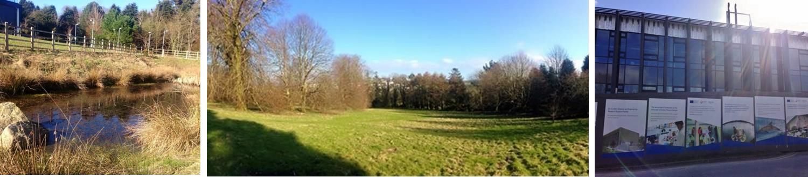

**6. Environmental Sustainability**

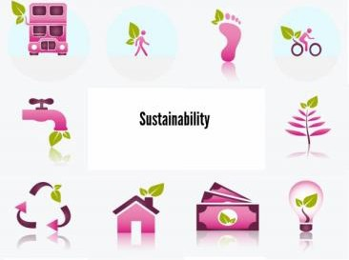

Falmouth Exeter Plus, Falmouth University (Falmouth) and the University of Exeter (UoE) aim to create a healthy, ecologically, economically and socially responsible living and learning environment for all students and staff, whereby the Penryn Campus is recognised both by the Higher Education (HE) Sector and within its local

community as a model of best practice in environmental sustainability. We recognise

our responsibility towards promoting the principles of one planet living; including minimising our use of non-renewable and/or scarce natural resources, appropriate

planning and investment in sustainable practices, the involvement of staff and students, and by providing an education in sustainability relevant to a world threatened by climate change.

Since 2009/10 all new development on the Penryn Campus has been designed to high environmental standards (at least BREEAM Excellent, and in the case of the new Environmental Sustainability Institute BREEAM Outstanding).

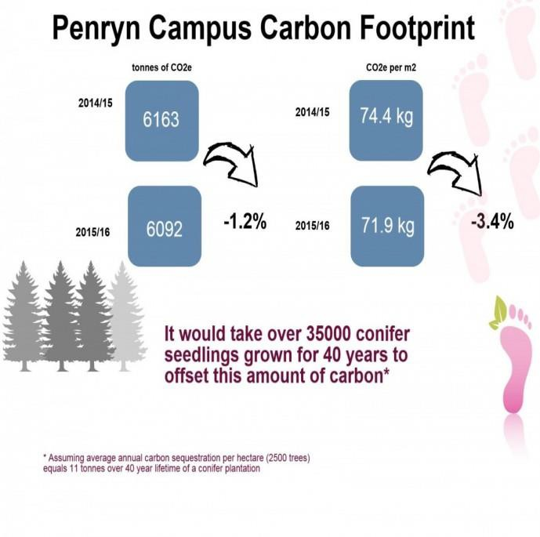

Infographic Carbon Footprint

**What we have achieved so far**

**Creation of a wildlife-friendly pond on campus**

Penryn campus contains several ponds; however the largest and most naturalistic pond is at some point in the near future to be lost as the site is to house a new building. As a large amount of wildlife will de pend on this pond as a source of water and as habitat it is important that it be

replaced with at least a pond of similar size. A SUD pond has currently been installed and the surrounding area will be developed as a wildflower meadow. The [EcoSoc](https://www.facebook.com/groups/44243270827/) (student society Exeter University) is currently writing the management plan for this area as it will be used for research projects.

**Increase use of peat free growing media, minimise use of peat**

Growing media containing peat is required for specialist ericaceous plants on campus, but further actions could be taken to minimise its use.

•  Instructions to all grounds staff on when to use peat free growing media and when peat use is acceptable would reduce unnecessary use of peat.

•  The establishing of nursery beds in the area of the gardeners compound would allow the grounds team to grow plants on in the open soil thus reducing the use of composts of all types as well as reducing the need for irrigation.

•  Less environmentally damaging sources of peat could be sought once consumption has been reduced to a level where the increased price of these products no longer makes this impractical.

A nursery bed has been established in the walled garden and is currently being used to grow on plants that would otherwise have required potting up. The team has also begun collecting topsoil discarded as molehills to mix with homemade compost to create loam based growing medium (less prone to drying).

**Chipping woody waste in situ to reduce transportation of waste**

Woody waste from tree pruning and hedge cutting has often been transported by tractor to the gardeners’ compound to be chipped. This can result in repeated trips to and from a work site when large amounts of waste are being produced. Chipping in situ, when practical, will reduce use of the tractor. This has been implemented and is in use whenever possible, greatly reducing tractor journeys. One way to develop on this is to use branches in certain areas to create habitat piles, saving the

carbon footprint of using the chipper.

**Turn off heating in drying room when not in use**

The radiator in the grounds team drying room has, up to now, been left on constantly so the room is always ready to dry wet clothes, boots and gloves. In long periods of dry weather, the room can go unused for days, during which time the radiators could be turned off in order to save

electricity. This has also been implemented, with a poster requesting staff turn off radiators when not in use and checks to make sure everything is off during dry spells. Team members will be reminded of this when the weather improves.

**Establish more composting bays around campus to reduce tractor use** As the team only currently have a single composting area at the Penryn campus, green waste must be regularly transported across the site by tractor. If areas could be found around campus where compost bays could be built then more waste could be taken to the nearest bay by wheelbarrow, with the resulting compost being returned to nearby areas

also by wheelbarrow, thus reducing use of the tractor and other vehicles. Sites for compost bays will need to be agreed by the head of estates. If sites are arranged, the construction and use of these areas can begin. As yet no additional compost bays have been created or sites agreed so this task is ongoing. However, in the meantime staff combine trips, storing green waste in dumpy bags until a vehicle is in the area.

As part of the Wasters project (student led) composting bin for f ood

waste will be installed at several locations near the student accommodation.

**Attach water butts to building downpipes**

The team has several buildings in close proximity to plant storage areas, if water butts could be attached to the downpipes of these buildings then the amount of rainwater harvested by the team would vastly increase, and irrigation of these plants could be done using this as opposed to mains water. Certain buildings are as yet not suitable for attaching water butts as plans for future development are being discussed. However a suitable building has been found where the butts could be used not just by the team but also by the home-grown society, and work to achieve this is ongoing.

**Increase planting of native trees and hedgerows around campus**

The team currently have several areas around Penryn campus where new woodland creation, regeneration of existing woodland, and hedgerow planting are being carried out. Some planting of native tree species has already been undertaken on these sites; however there is scope for further tree planting projects in these areas.

Many more trees have been planted on campus, including the woodland regeneration site, hedgerow thickening and the planting of a nut orchard.

However this work was all undertaken by the grounds team so the goal of involving other campus users in tree planting remains ongoing.

**Establish wildlife havens free from active management**

While those areas of the campus that are most heavily used must be kept to a high standard of presentation, the presence of scrub and wild flower and grasses in less used areas should not imply neglect but rather that these areas are set aside for the benefit of wildlife. This is especially important as several courses offered by the universities on campus involve the study of wildlife. If such areas could be declared wildlife havens, to be free of active management, this would ensure the habitats they contain will be free from damage in the interests of tidying, and will allow natural succession of plant and animal species to take place.

Several important areas have been identified where the current occupation by native trees, scrub and grasses are particularly important and work to protect these from development is ongoing (e.g. tree protection zones to keep building work clear of hedgerows.).

**Improve upkeep of beehives**

The team had several beehives on site but due to the promotion of those team members with the expertise in beekeeping, and the accompanying increase in workload, the upkeep of these hives has taken a back seat. It is recommended either that additional members of the team be given training in beekeeping so that the hives can be properly maintained or else the team could invite volunteer beekeepers from the local

community to use the hives.

**Encouraging team members to turn off lights and electric equipment when not in use**

The team’s welfare building contains 2 computers as well as electrical

lighting and heating. The computers and lights can sometimes be left on when no-one is using the building, especially the PC monitors. Posters have been made and a check is made at the end of each day as well as during the day to ensure lights and computers are off when not in use.

**Bioblitz**

Bioblitz is a 24hour wildlife surveying event taking place on and around the Penryn Campus with the aim of creating as big a database as possible of the rich biodiversity we have here.

**EcoSoc**

Naturewatch is run by student societies EcoSoc and WildDocSoc, along with the College of Life and Environmental Studies. Each episode is filmed, produced and presented by students from both the University of Exeter and Falmouth University. Have a [look](https://www.youtube.com/watch?v=AODIuWuaVV8) what is going on Penryn Campus!



**Events**

Outreach events, such as the Open day (19th June 2016) and the Apple Pressing day (5th October 2016/17) were welcomed by the wider community, staff and students and will be repeated in the future. A grand Garden Festival will be held on Saturday 5th May 2018.

**Transport and travel**



Our Green Travel Plan expresses our commitment to developing provision for pedestrians, cyclists and for multi -modal transportation including public transport.

The Key Objectives of this Travel Plan are to:

•  reduce the environmental impact of travel associated with both Institutions;

•  reduce parking congestion on campus and in the locality during term -time;

•  improve the options available for travel to both campuses;

•  improve the safety and accessibility of travel within and to both campuses.

Measures aimed at addressing these objectives between 2016-2021 are laid out within the Plan and include improving public transport provision, improved facilities for cycling and walking, improved car park management, and the ongoing examination of parking restrictions and charging. Both Institutions encourage students, staff and visitors to consider using alternative methods of transport to help reduce the impact of car travel on the environment. By working

in close partnership with Cornwall Council and other strategic partne rs, both institutions endeavour to continue developing and improving the range of travel options available to members of the Universities, as well as visitors. Detailed information on specific modes of transport available to staff and students can be found within our website. However, to be mentioned here is the successful, subsidised bus services between our Falmouth and Penryn campuses. Staff and students pay £ 1 for a single bus journey. Passengers’ trips have increased by

50% in the last year compared to 2014. This includes the use of the Uni Mussel

card which is an annual travel card to be used on buses in Cornwall, maritime line, ferries and some shops.

The campus continues to increase its provision of bike racks and reduce its commitment to car use, as part of its sustainability carbon management strategies and green travel plan. The positive aspects of the grounds and its integrated sculptures are also promoted to staff, students and visitors through the publication on the websites.

The geography of the main campus provides natural challenges to ‘all ability’ access, but, wherever possible and practical, surfaces and entrances have been adjusted, and dedicated disabled parking bays are provided.

All visitors to the campus are encouraged to use alternative methods of transport and avoid driving to the campus wherever possible. Students and staff who live in the local area (Falmouth and Penryn) are able to use the U1, U2 and U3 buses for just £1 per journey – there are 8 bus services running each hour. There are also regular trains running between Falmouth and Truro which cost from £2.60 for a return. We ask that students and staff use alternative methods of transport and avoid driving to the campus wherever possible. Our [car parking charter](http://www.fxplus.ac.uk/sites/default/files/documents/car_parking_charter_2016_final.pdf) has more information and advice.

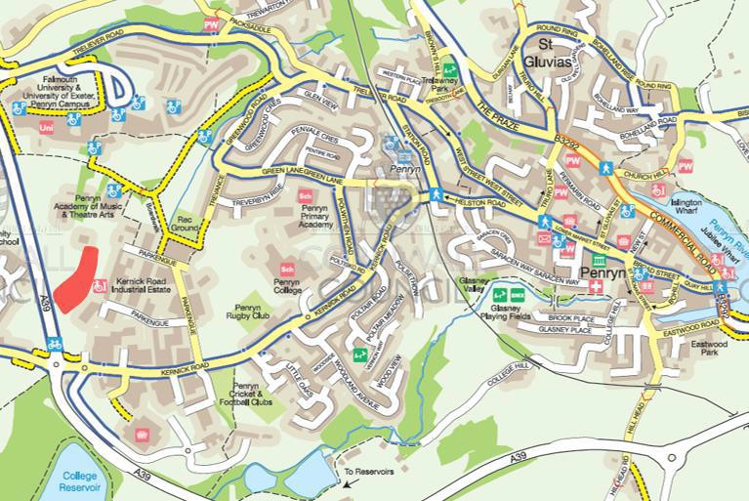

Local cycle and walking routes

**8. Conservation and Heritage**

**Why Conserve Biodiversity?**

From habitat destruction and pollution to our excessive use of natural resources, humans are taking their toll on the natural systems which support life on our planet. According to the ‘Millennium Ecosystem Assessment’, global species extinction rates are now up to 1000 times higher than the historical rate shown by the fossil record. This is expected to increase 10 fold over the

next 50 years. In the UK, humans have had a massive influence on biodiversity

since Neolithic times. New pressures arose with the advent of the Industrial Revolution and the Second World War. Farming methods have become more intensive and there has been rapid construction of new roads, houses, towns and cities. The extent and quality of semi-natural habitats and the number of species that depend on them has progressively declined. Even bird species such as the house sparrow and starling, that were common and widespread just a decade or two ago, have undergone major decline. Serious action is required now on a global, national and local scale to slow down the loss of our natural heritage and everyone has an important role to play in this.

It is easy to see why nature conservation can get dropped from the Environmental and Estates priority list. In reality there is a huge potential to make a difference to the conservation of our biodiversity on our campuses.

Much is to be gained to create and maintain a healthy campus biodiversity.

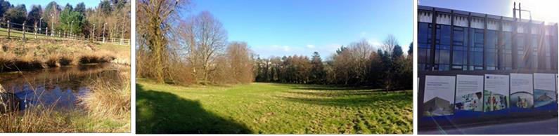

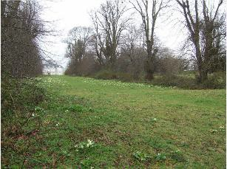

Cornish hedgerows Lime grove

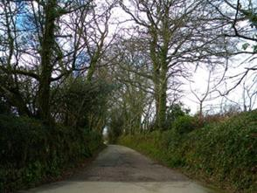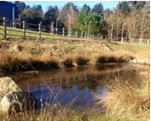

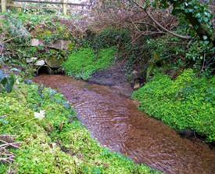

Penryn river

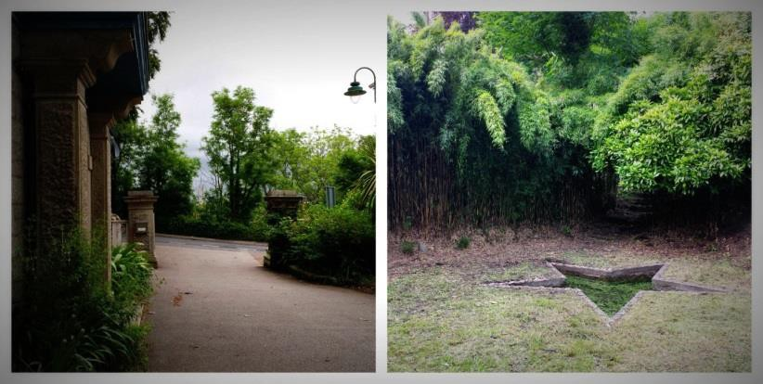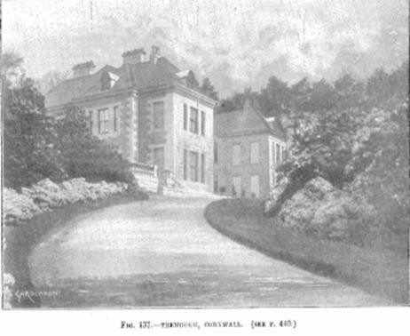

**History Tremough Gardens**

The land occupied by the University Campus is a historic one; archaeological digs have uncovered evidence of human settlers from as early as the Neolithic and Bronze ages. The original name for the site was Tremough (meaning pig farm) with the estate as we know it built in 1704 by Sir John Worth, who constructed Tremough House (top right) and the avenue of Lime trees which is now under protection. There are a number of trees protected on campus due

to both historical and ecological reasons, providing much needed mitigation against development on these plots of land. Lime leaves provide an excellent food source for the juvenile stages of many moth species. The flowers provide nectar and pollen for insects, predominantly bees. Long lived trees can provide rich dead wood habitats for boring beetles and nesting holes for birds.

During the 1800s, estate owners of Tremough created the Italian Gardens. This amenity grassland is best described as park land with scattered trees; native and non-native conifers and deciduous species. The dominant species here are ornamental shrubs such as Lavender, Buddleia and Hydrangea. These are all plants that are attractive to insects, however, there is some discussion as to whether the non-native species should be removed. At present the gardening team have chosen to maintain these bushes to attract wildlife. Terraces planted with specimen Magnolias- ancient trees thought to be around

20 million years old –and Azaleas, are also a dominant feature of this area.

The walled garden was also thought to be created at this point. It contains the remains of the original Paxton Greenhouses – built by Sir Joseph Paxton, a renowned English gardener and architect, in 1849. As well as historical significance, the walled garden is home to a protected and productive orchard containing native varieties.

Tremough became famous in the Victorian era for its collection of

Rhododendrons, some of which are thought to be a rare Himalayan species.

Some of these beautiful flowering plants are hybrids; t he most famous of these, “The Beauty of Tremough” still flourishes throughout the campus site, particularly along the walkways leading to the south-east boundary. Despite this not being a native plant, this collection is invaluable and is of great interest to enthusiasts that travel across the world to visit it.



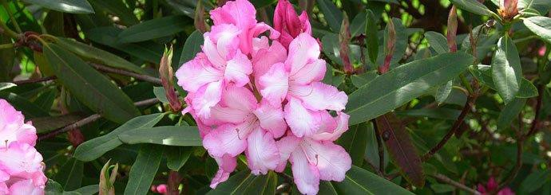

The Beauty of Tremough

**10.Community Involvement**



**Community**

Our award winning Tremough Gardens at Penryn Campus are open for all to enjoy. Visitors can take in the walled garden, herbaceous beds, sub-tropical planting, fruit producing orchard, Italian garden and terraces, the 18th Century lime avenue, parkland, the old drive with pinetum native woodlands and the historic rare Rhododendrons, cultivated on the site in the Victorian era. Meanwhile, in Wood Lane, the Falmouth Campus’ sub-tropical planting blends seamlessly with Fox Rosehill Gardens.

Its current amenities include car parks (restrictions and charges apply), shops, cafes, facilities and toilets. It has many landscape features such as ponds, courtyard gardens and watercourses with seating.

We have begun a process of improving our interpretation of the grounds with signage explaining Ecology and Biodiversity principles as well as self-guided Sculpture and Grounds tours.

As higher education provision in Falmouth and Penryn grows in size we want to do everything we can to increase positive interaction between students, staff and local residents. We're keen to get involved with our neighbours and encourage everyone to take advantage of the **facilities** and **activities** we have available. We have also developed several **initiatives** to encourage positive dialoque and interaction between students, staff and other residents.

To keep the community informed and involved, together with Falmouth University (Falmouth and Penryn), the University of Exeter Cornwall Campus (Penryn) and the Falmouth and Exeter Students’ Union, FXU (Falmouth and Penryn), our aim is to share with them what we are doing to:

* strengthen our relationships in the community and with local businesses
* address any concerns you might have and involve you in resolving them
* encourage and support students to engage fully in local life
* listen, respond, join in, support and make a positive contribution to our local area.

**11.Facilities**

**Our Falmouth and Penryn campuses are an important community resource** **everyone can enjoy.**

Our facilities are among the best in the Europe and we are proud of the exceptional learning environment that our students enjoy. But our campuses are not just for students – we encourage everyone to use and enjoy our facilities.

For example:

• Join the [Penryn Campus Fitness Centre](http://www.fxplus.ac.uk/our-services/sports-recreation), offering membership subscriptions or pay as you go use of the gym and fitness classes. Plus our brand new sports centre with four court sports hall, will be available for hire.

• Make use of our children's day nursery at Woodlane in Falmouth. Find out more on [our nursery pages](http://www.fxplus.ac.uk/our-services/woodlane-nursery).

• The community is welcome to use and join our reference libraries at both our Penryn and Falmouth campuses. Find out more, including details of our collections, special events and how to register with on our [Library website](http://library.fxplus.ac.uk/library/how/external-membership).

• We encourage local community groups – from local brass bands to the Girl

Guide Association – to use our facilities, offering discounted hire rates. For further details, see our [Conference and Events](http://www.fxplus.ac.uk/our-services/conference-events) section or telephone our Conference and Events team on 01326 370466.

• Photography print services and photographic equipment and facilities hire are also available by contacting Craig Farley (01326 254110 [/ craig.farley@falmouth.ac.uk](mailto:254110/craig.farley@falmouth.ac.uk)) and Scooby Gill (01326 213703 / [alexis.gill@falmouth.ac.uk)](mailto:alexis.gill@falmouth.ac.uk) respectively

• You are also welcome to access our reprographics services, cafes, shop and the multi-use games area.

• Affordable accommodation for visiting family and friends is available, during

July and August we offer rooms and flats at the Penryn Campus which offer an excellent base to explore Cornwall. Find out more at [www.cornwall-plus.co.uk](http://www.cornwall-plus.co.uk/).

**Activities**

• Visit our [campus gardens](http://www.fxplus.ac.uk/our-services/our-gardens) and grounds for walking and leisure. The Penryn Campus is open to the public and the Walled Garden is open from dawn until dusk.

• Campus talks and tours are available for local community groups, such as gardening clubs and the Rotary.

• Many exhibitions, events, lectures and talks are open to the public and we encourage you to attend. These are advertised in our [events section](http://www.fxplus.ac.uk/events), in the local media and on community noticeboards.

• The Friends of Penryn arrange events at the Campus and produce regular newsletters. To join, email [friendsoftremough@gmail.com](mailto:friendsoftremough@gmail.com).

•   Exhibitions, events, talks and lectures at the Falmouth and Penryn Campuses that you are most welcome to attend, including annual events such as Falmouth University's Summer Festival and the cross-institutional Penryn Campus Culture Festival; as well as live music, theatre and dance at the Performance Centre throughout the year. These events are advertised on our What’s On guide, in

the local media and on community noticeboard

**12. Marketing**

|  |  |  |  |
| --- | --- | --- | --- |
| **Communications and social marketing plan why we need social marketing**  Marketing is about creating an exchange where both parties can benefit and is often seen as a driver of ever growing consumerism and unsustainable use of resources. Social marketing is an approach used to develop activities aimed at changing or maintaining people’s behaviour for the benefit of individuals and society as a whole. In the interest of biodiversity and the stakeholders a social marketing approach is more sustainable and desirable.  **why we need to market Tremough gardens**  •  to engage effectively with stakeholders; community, students, staff and  Board  •  to demonstrate the success of our work  •  to ensure people understand what we do  •  to change behaviour and perceptions where necessary  •  for funding purposes  •  for award purposes  **SWOT** | | | |
|  | **Strengths**  •  **beautiful estate gardens steeped in history including an Italianate garden**  •  **easily accessible**  •  **free to enter**  •  **open all year round**  •  **reconnecting people to nature**  •  **holistic approach**  •  **increased societal engagement**  •  **award winning** | **Opportunities**  •  **increasing environmental awareness to stakeholders**  •  **to raise funding opportunities**  •  **to apply for awards**  •  **to organise events including all stakeholders**  •  **to be innovative with less grounds**  •  **awareness of strategy and policy**  •  **research opportunities** |  |
| **Weaknesses** | **Threats** |

•  **location of gardens not well known**

•  **lack of resources**

•  **benefits poorly understood**

•  **little communication to local community and other stakeholders**

•  **resistance to sustainable approach**

•  **insufficient funding**

•  **lack of awareness across stakeholders**

•  **buildings taking over habitat**

•  **fungal diseases**

**Title: Biodiversity**

**Start date: September 2016**

**Director: Tim Brooksbank**

**Completion date: Ongoing to 2021**

**Project Manager: Marja van Loef**

**Review: annually**

**Communications: Marja van Loef**



**Context–** (background information to inform project and communications)

Biodiversity management as part of Facilities and Estates management remit for

Penryn Campus.

Biodiversity a key part of the Environmental Sustainability strategy (UoE, Falmouth

FX Plus)

Biodiversity strategy and action plan to inform communications and social marketing plan

**Communications Objectives:**

Promote the actions within in the Biodiversity Strategy to meet the targets of

•  By 2021, at the latest, people are aware of the values of biodiversity and the steps they can take to conserve and use it sustainably

•  Communicate the history and uniqueness of the Penryn Campus

•  Work alongside the universities and other departments within FX Plus to increase awareness of the gardens



|  |  |
| --- | --- |
| •  Use expertise of staff and other stakeholders to assist with communicating  benefits and distinctiveness of the campus  •  Identify and communicate how campus growth and protecting biodiversity can co-exist  •  Enhance the award winning reputation of the gardens | |
| **Communications Issues/Risks:**  •  Facilities not available or convenient  •  People don’t act on the messages  •  Other priorities for colleagues  •  Resources available for promotion | |
| **Primary audiences:**  FX Plus staff Students Board Community UoE staff Falmouth staff FXU  **Key internal stakeholders:**  FX Plus operations  Carbon and sustainability Manager  Procurement | **External Audiences**  Community Funders Awarding bodies  **Other key external stakeholders** Conservation charities/organisations Suppliers  Prospective students and families  Local residents and councillors  (Cornwall, Penryn, Falmouth) General public (reputation) Other universities |



|  |  |
| --- | --- |
|  |  |
| **Communications Approach / Strategy**  1. Development of messages and materials to promote take up of actions within the Strategy  2. Develop and implement a planned communication campaign, using  existing communication channels, maximising impact from local, partner and national initiatives.  3. Develop use of website, social media and other channels to promote biodiversity initiatives and messages as appropriate  4. Communication channels; on-site interpretation, electronic media; facebook page, website, twitter, internal publications, local media, campus events | |
| **Key messages:**  •  FX Plus commitment to encourage engagement with the environment  •  #GreenerCampus  •  Do more think ‘less’ | |



**13.**

**Actions 2016-2021**

Actions will be reviewed annually and, if needed, new SMART KPIs for biodiversity will be identified as indicators of success.

|  |  |
| --- | --- |
| **Action 1: Conservation** | |
| **Financial**  **framework: Current state:**  **Objective**  **Description of activities:**  **Monitoring method:**  **Indicator of success:**  **Stakeholders:** | tbc |
| As described in current initiatives, 1,2,3,5,6,7,8 and 9 |
| To enhance and create new habitats across both campuses |
| •  Regular meetings  •  Annual update Strategy and Action plan  •  Annual Bioblitz survey  •  Annual Risk Assessment  •  Increasing awareness for Biodiversity  •  Communication to internal and external stakeholders |
| Bioblitz Survey  Actions |
| •  Results Bioblitz  •  Changes in habitat map  •  All tree planting must be 100% native species  •  Number of tree remain the same as when a tree is removed it needs to be replaced (stability trees on campus)  •  BAP  •  Reduction of the use of residual pesticides  •  Increase of use of non-residual and biological/non- chemical techniques  •  Awards  •  Number of bird and bat boxes  Number of beehives |
| Students  Planning Team |



|  |  |
| --- | --- |
| **Actions 2016-**  **2021** |  |
| **What Where Time**  **scale** |
| Ensure blue areas of ongoing  wildflower/species grassland rich grassland |
| Increase tree campus ongoing  replacement  planting from 3 for 1 |
| Replace grassed edges of campus end of  areas with low level 2017 usage with floristic  grasslands |
| Mowing less areas not directly ongoing  frequently, around University encourage buildings wildflower meadows |
| boundaries of ongoing  campus and around  Continue to thicken carparks  foliage |
| Remove bramble boundaries of ongoing  and ground ivy campus and around  (from a tidiness carparks point of view) |
| Keep scrub areas boundaries of ongoing  campus and around carparks |
| Encourage scrubland new developments- end of  around the boundary new residences 2016 |

Where hazel scrub is mature enough,

start coppicing

practise

north of campus near road

winter

2016/17

Improve boundary margin through increased hedgerow diversity and implement a strip of wildflowers around

the hedge

boundaries of campus and bottom fields

ongoing

Ensure hedgerows used by bats are carefully maintained

and not destroyed

hedgerows of bottom fields

ongoing

Introduce new plant species

boundaries of campus

ongoing

Change some hedgerows into

edible plants such as

blackberries to encourage their popularity and apple

trees

non protected hedgerows/accessible hedgerows

end of

2016

Postpone cutting, as much as possible,

until February/March

all hedgerows annually

Clean out star pond and make more accessible to amphibians

star pond ongoing

Clear leaves and debris from walled

garden

walled garden pond ongoing

SUD (sustainable drainage) pond

FX Plus estates Office completed

Exclusion zone around streams for

future developments

around streams currently undertaken

Development of exclusion zone around streams for

future developments

around streams 2016/17

Thicken foliage around streams

around streams 2017/18

Increase areas of hibernacula for

protected species

across campuses ongoing

Using peat free compost reduces

footprint

across campuses ongoing

Efficient irrigation;

looking at watering systems

across campuses ongoing

Composting;

different compost bays on campuses

across campuses ongoing





|  |  |  |
| --- | --- | --- |
| **Action owner/s** | Sustainable weed  management (weed act 1959) | across campuses 2017/18 |
|  | |
| The Grounds team  Planning Team and Architects | |

|  |  |
| --- | --- |
| **Action 2: Procurement** | |
| **Financial framework:**  **Current state:**  **Objective**  **Description of activities:**  **Monitoring method: Indicator of success:**  **Stakeholders:**  **Actions 2016-2021** | tbc |
| Equipment is only purchased when absolutely  necessary and re-used  Plants are purchased in local nurseries |
| to encourage staff to question the need for new items,  the quantity purchased, and to consider alternative solutions such as reuse, rental and sharing resources so that specifications are functional and not over- specified |
| •  Regular meetings/discussions purchases  •  Research purchases  •  Annual update Strategy and Action plan  •  Communication to internal and external stakeholders |
| Number of purchases annually, the re-use of items,  rental and shared items |
| Number of items re-used, rented or shared |
| Procurement  Local retailers |
| Continuation of purchasing/sharing/renting ongoing  eco/local products |



|  |  |
| --- | --- |
| **Action owner/s** | Re-use/rental/sharing of machinery ongoing |
| Continuation of purchasing local plants ongoing |
| The Grounds team  FX Plus-Estates |

|  |  |
| --- | --- |
| **Action 3: Buildings** | |
| **Financial framework:**  **Current state:**  **Objective**  **Description of activities:**  **Monitoring method:**  **Indicator of success:**  **Stakeholders:** | na |
| * Use of sustainable drainage techniques * Inclusion of significant habitats on buildings, i.e. green/brown roofs and living walls * SUD pond (sustainable drainage pond) |
| Ecological impacts on buildings |
| •  Regular meetings  •  Annual update Strategy and Action plan  •  Increasing awareness for Biodiversity in the construction on campuses  •  Communication to internal and external stakeholders  •  Landscaping and other consultancy reports |
| Number of buildings implementing green  habitats  Number of SUDS  Other use of sustainable construction methods |
| Number of buildings implemented green habitats  Impact of SUD  Impact it has on other construction on the campuses |
| Architects  Project planners  Ecology consultants |



|  |  |
| --- | --- |
| **Actions 2016-2021**  **Action owner/s** | The inclusion of biodiversity integrated in  buildings is included in the brief for all  relevant building projects in response to a 2018 campus wide policy. Issues such as and maintenance and communications are well beyond  understood and implemented. |
| Ensure procedures are put in place for all 2017  new developments/projects which may and have an impact on biodiversity to be beyond assessed for impact and mitigation  measures |
| Sustainable drainage hierarchy (or similar) 2017  is included within the brief for all relevant and construction beyond |
| Green/brown/sea thrift roofs to delay 2017/18  rainwater run-off |
| Hedgerows used by bats need to be ongoing  carefully maintained therefore need to know the planning of buildings |
| Use of Bat bricks 2017/18 |
| The Grounds team  FX Plus-Projects  Sustainability Manager |

|  |  |
| --- | --- |
| **Action 4: Partnerships** | |
| **Financial framework:**  **Current state:** | na |
| Working with the community  Working with charities for example WWF Research specialist organisations |



|  |  |  |
| --- | --- | --- |
| **Objective**  **Description of activities:**  **Monitoring method: Indicator of success: Stakeholders:**  **Actions 2016-2021**  **Action owner/s** | Working together in Partnerships | |
| •  Regular meetings  •  Research  •  Annual update Strategy and Action plan  •  Increasing awareness for Biodiversity  •  Communication to internal and external stakeholders | |
| Number of successful projects/initiatives | |
| Number of successful projects/initiatives | |
| Specialist organisations such as Woodland Trust,  Wildlife Trust etc. Other Universities | |
| Exchange gardeners other universities 2017/18 | |
| Wildflower seeding project WWF 2017/18 | |
| Project Tree-economics 2017/18 | |
| Eco Green Consultants Project;  management plans (tree survey/weed management/wildflower meadow) | 2016/17 |
| The Grounds team  Universities | |

**Action 5: Funding**

**Financial framework:** NA

**Current state:** NA

**Objective** Funding and grants for initiatives/projects

|  |  |
| --- | --- |
| **Description of activities:**  **Monitoring method: Indicator of success:**  **Stakeholders:**  **Actions 2016-2021**  **Action owner/s** |  |
| None so far |
| Number of successful and unsuccessful applications |
| Amount of money received  Number of completed projects |
| Alice McCosh Trust  Biffa Awards  Sita trust |
| Apply for funding 2017 and beyond |
| FX Plus-Estates |

|  |  |
| --- | --- |
| **Action 6: Volunteering and training** | |
| **Financial framework:**  **Current state:**  **Objective**  **Description of activities:**  **Monitoring method:** | tbc |
| None  Availability grounds for educational purposes/  relevant courses |
| Working with volunteers; staff, students or from the  community |
| •  Recruitment volunteers; students/staff  •  Regular meetings  •  Training, for example bee training, peat free growing media  •  Annual update Strategy and Action plan  •  Increasing awareness for Biodiversity  •  Communication to internal and external  stakeholders |
| Number of volunteers |



|  |  |  |
| --- | --- | --- |
| **Indicator of success: Stakeholders:**  **Actions 2016-2021**  **Action owner/s** | Number of training sessions | |
| Number of volunteers  Number of training sessions | |
| Community  Staff  FXU | |
| Environmental training grounds staff 2017  and beyond | |
| Sustainable weed control training 2017/18 | |
| Growing vegetables, hanging baskets, ongoing  herbs etc. promoting healthy lifestyle | |
| Involvement in allotments with FXU 2016/17 | |
| Development SUD pond area into 2016/17  wildflower meadow-EcoSoc | |
| Involvement Green initiatives FXU;  working in collaboration with Intern and  FXU | 2016/17 |
| The Grounds team  FXU Staff Community | |

|  |  |
| --- | --- |
| **Action 7: Healthy living** | |
| **Financial framework:**  **Current state: Objective**  **Description of activities:** | NA |
| Jogging/Running/walking around the campuses  Martial Arts in the Italian Gardens |
| to promote healthy living and well being |
| None at the moment |

|  |  |
| --- | --- |
| **Monitoring method:**  **Indicator of success: Stakeholders:**  **Actions 2016-2021**  **Action owner/s** | Number of participants |
| Number of participants |
| The Gym  Staff Students Community |
| Setting up of a green gym 2016/17 |
| Health walks 2016/17 |
| Edible trails 2016/17 |
| Running/walking routes 2016/17 |
| The Grounds team  The Gym |

|  |  |
| --- | --- |
| **Action 8: Legislation** | |
| **Financial framework:**  **Current state: Objective**  **Description of activities:**  **Monitoring method: Indicator of success:** | None |
| Being updated |
| To adhere to environmental and other legislation |
| none so far |
| Annual check ups |
| Annual check ups |

|  |  |
| --- | --- |
| **Stakeholders:**  **Actions 2016-2021**  **Action owner/s** | Environment Agency  Office of Public Sector Information  DEFRA UK Act |
| •  [Weeds Act 1959](http://www.opsi.gov.uk/RevisedStatutes/Acts/ukpga/1959/cukpga_19590054_en_1) Acts need  •  Plant Health Act 1967 (and updating Statutory Instruments SI2015/610, and SI2016/104) annually  •  Control of Pesticides Regulations  1986 (SI 1986/1510) checked  [•  Plant Protection Products (Basic](http://www.hmso.gov.uk/si/si1997/19970189.htm?lang=_e)  [Conditions) Regulations 1997 SI](http://www.hmso.gov.uk/si/si1997/19970189.htm?lang=_e)  [189](http://www.hmso.gov.uk/si/si1997/19970189.htm?lang=_e)  •  The Plant Protection Products  (Sustainable Use) Regulations 2012  •  [Protection of Badgers Act 1992](http://www.opsi.gov.uk/acts/acts1992/Ukpga_19920051_en_1.htm?lang=_e)  2010/609  [•  Environment Act 1995 (c.25) (As amended)](http://www.opsi.gov.uk/acts/acts1995/Ukpga_19950025_en_1.htm)  [•  Town and Country Planning (Trees) Regulations 1999 (SI 1999/1892)](http://www.legislation.gov.uk/uksi/1999/1892/contents/made)  [•  Countryside and Rights of Way Act](http://www.opsi.gov.uk/acts/acts2000/ukpga_20000037_en_1)  [2000 (as amended by SI](http://www.opsi.gov.uk/acts/acts2000/ukpga_20000037_en_1)  [2007/1843, SI 2002/1794 and SI](http://www.opsi.gov.uk/acts/acts2000/ukpga_20000037_en_1)  [2007/3538](http://www.opsi.gov.uk/acts/acts2000/ukpga_20000037_en_1)  [•  Natural Environment and Rural](http://www.legislation.gov.uk/ukpga/2006/16/contents)  [Communities Act 2006](http://www.legislation.gov.uk/ukpga/2006/16/contents)  [•  DCLG Guidance: Tree Preservation Orders - A Guide to the law and good practice ~ Addendum September 2008](http://www.communities.gov.uk/publications/planningandbuilding/tposguide)  [•  Wildlife and Countryside (Registration and Ringing of Certain Captive Birds) (Amendment) (England) Regulations 2008 (SI](http://www.legislation.gov.uk/uksi/2008/2357/contents/made)  [2008/2357)](http://www.legislation.gov.uk/uksi/2008/2357/contents/made)  [•  The Conservation of Habitats and](http://www.legislation.gov.uk/uksi/2010/490/contents/made)  [Species Regulations 2010 No. 490](http://www.legislation.gov.uk/uksi/2010/490/contents/made)  Source: EAUC practical guide, legal advice |
| The Grounds team  Director of FXPlus  Community |

|  |  |
| --- | --- |
| **Action 9: Waste Management and Litter** | |
| **Financial**  **framework: Current state:**  **Objective**  **Description of activities:**  **Monitoring method:**  **Indicator of success:**  **Stakeholders: Actions 2016-**  **2021** | na |
| Waste policy  Green impact initiatives |
| To minimise waste and litter on the campuses |
| •  See Waste Strategy and Action plan  •  Regular meetings  •  Annual updates Biodiversity Strategy and Action plan  •  Storing green waste |
| Measuring tonnages garden waste  Measure ‘wasters’ waste |
| Tonnage of garden waste  ‘wasters’ waste |
| FXU Wasters |
| Wasters programme-composting and other 2016/17  recycling; audits students |
| Gardeners patrol and control litter ongoing |
| Reminders not to litter, in particular dog waste 2016/17 |
| Provision of bins; more dog waste bins 2016 |

|  |  |  |
| --- | --- | --- |
| **Action owner/s** | Motorised sweeping ongoing | |
| Develop a methodology to estimate the tonnage of  garden waste composted, logged or chipped | 2017 |
| Establish more composting bays around campus to ongoing reduce tractor use | |
| The Grounds team  FXU Community | |

|  |  |
| --- | --- |
| **Action 10: Events and raising awareness** | |
| **Financial framework:**  **Current state:**  **Objective**  **Description of activities:** | tbc |
| Currently low key events; open day and apple  pressing days  Facebook page Biodiversity BAP (Biodiversity Action Plan) Community Unity newsletter |
| To maintain and create interest in environmental  issues on the campuses |
| •  Organising events  •  Maintenance Facebook page  •  Regular meetings  •  Annual updates Biodiversity Strategy and Action plan |

|  |  |
| --- | --- |
| **Monitoring method:**  **Indicator of success:**  **Stakeholders:**  **Action owner/s** | Events  Publications |
| Number of events  Number of participants  Number of publications |
| FXU  External stakeholders Volunteers Community |
| Apple pressing day 5th October  2017/18 |
| Planting, en masse, bulbs Winter 2018 |
| Garden Fete; a grand open day for 5th May 2018  the community to showcase what we are doing and have fun! |
| The Grounds team  FXU Community |
|  |  |
|  |  |

**14. Season schedule**

|  |  |  |  |  |  |  |  |  |  |  |  |  |  |  |  |  |  |  |  |  |  |  |  |  |  |  |  |  |  |  |  |  |  |  |  |  |  |  |  |  |  |  |  |  |  |  |  |  |  |  |  |  |  |  |  |  |  |  |  |  |  |  |
| --- | --- | --- | --- | --- | --- | --- | --- | --- | --- | --- | --- | --- | --- | --- | --- | --- | --- | --- | --- | --- | --- | --- | --- | --- | --- | --- | --- | --- | --- | --- | --- | --- | --- | --- | --- | --- | --- | --- | --- | --- | --- | --- | --- | --- | --- | --- | --- | --- | --- | --- | --- | --- | --- | --- | --- | --- | --- | --- | --- | --- | --- | --- |
|  | **Task** | **Frequency** | **JAN** | **FEB** | **MAR** | **APR** | **MAY** | **JUN** | **JUL** | **AUG** | **SEP** | **OCT** | **NOV** | **DEC** |  |  |  |  |  |  |  |  |  |  |  |  |  |  |  |  |  |  |  |  |  |  |  |  |  |  |  |  |  |  |  |  |  |  |  |  |  |  |  |  |  |  |  |  |  |  |  |  |
| **Formal Lawns** | **Cutting** | **Weekly/twice weekly** |  | **XX** | **XXX** | **XXXX** | **XXXX** | **XXXX** | **XXXX** | **XXXX** | **XXXX** | **XX** | **X** |  |  |  |  |  |  |  |  |  |  |  |  |  |  |  |  |  |  |  |  |  |  |  |  |  |  |  |  |  |  |  |  |  |  |  |  |  |  |  |  |  |  |  |  |  |  |  |  |  |
|  | **Scarify, rake, aerate** | **Seasonal/as required** |  |  |  | **X** | **X** |  |  |  | **X** | **X** |  |  |  |  |  |  |  |  |  |  |  |  |  |  |  |  |  |  |  |  |  |  |  |  |  |  |  |  |  |  |  |  |  |  |  |  |  |  |  |  |  |  |  |  |  |  |  |  |  |  |
|  | **Fertilizer** | **Spring/Autumn** |  |  | **X** |  |  |  |  |  |  | **X** |  |  |  |  |  |  |  |  |  |  |  |  |  |  |  |  |  |  |  |  |  |  |  |  |  |  |  |  |  |  |  |  |  |  |  |  |  |  |  |  |  |  |  |  |  |  |  |  |  |  |
|  | **Edge cutting** | **Weekly** |  |  | **XX** | **XX** | **XX** | **XX** | **XX** | **XX** | **XX** | **X** |  |  |  |  |  |  |  |  |  |  |  |  |  |  |  |  |  |  |  |  |  |  |  |  |  |  |  |  |  |  |  |  |  |  |  |  |  |  |  |  |  |  |  |  |  |  |  |  |  |  |
|  | **Blow leaves** | **Weekly** | **X** |  |  |  |  |  |  |  | **X** | **XXX** | **XXX** | **X** |  |  |  |  |  |  |  |  |  |  |  |  |  |  |  |  |  |  |  |  |  |  |  |  |  |  |  |  |  |  |  |  |  |  |  |  |  |  |  |  |  |  |  |  |  |  |  |  |
|  | **Moss killer/top dress** | **Twice yearly** |  |  |  | **X** |  |  |  |  |  |  | **X** |  |  |  |  |  |  |  |  |  |  |  |  |  |  |  |  |  |  |  |  |  |  |  |  |  |  |  |  |  |  |  |  |  |  |  |  |  |  |  |  |  |  |  |  |  |  |  |  |  |
|  | **Herbicide application** | **Seasonal/as required** |  |  |  | **X** |  | **X** |  | **X** |  |  |  |  |  |  |  |  |  |  |  |  |  |  |  |  |  |  |  |  |  |  |  |  |  |  |  |  |  |  |  |  |  |  |  |  |  |  |  |  |  |  |  |  |  |  |  |  |  |  |  |  |
|  | **Tree circle** | **As required** |  | **X** |  | **X** |  | **X** |  | **X** |  | **X** |  | **X** |  |  |  |  |  |  |  |  |  |  |  |  |  |  |  |  |  |  |  |  |  |  |  |  |  |  |  |  |  |  |  |  |  |  |  |  |  |  |  |  |  |  |  |  |  |  |  |  |
|  | **Water** | **Weather dependant** |  |  |  |  |  | **X** | **X** | **X** |  |  |  |  |  |  |  |  |  |  |  |  |  |  |  |  |  |  |  |  |  |  |  |  |  |  |  |  |  |  |  |  |  |  |  |  |  |  |  |  |  |  |  |  |  |  |  |  |  |  |  |  |
|  |  |  |  |  |  |  |  |  |  |  |  |  |  |  |  |  |  |  |  |  |  |  |  |  |  |  |  |  |  |  |  |  |  |  |  |  |  |  |  |  |  |  |  |  |  |  |  |  |  |  |  |  |  |  |  |  |  |  |  |  |  |  |
| **Car Parks** | ***Mow Lawns*** | ***Weekly/Twice weekly*** | **x** | **X** | **XXX** | **XXXX** | **XXXX** | **XXXX** | **XXXX** | **XXXX** | **XXXX** | **XX** | **X** |  |  |  |  |  |  |  |  |  |  |  |  |  |  |  |  |  |  |  |  |  |  |  |  |  |  |  |  |  |  |  |  |  |  |  |  |  |  |  |  |  |  |  |  |  |  |  |  |  |
|  | ***Blow gravel*** | ***Daily*** | **X** | **X** | **X** | **X** | **X** | **X** | **X** | **X** | **X** | **X** | **X** | **X** |  |  |  |  |  |  |  |  |  |  |  |  |  |  |  |  |  |  |  |  |  |  |  |  |  |  |  |  |  |  |  |  |  |  |  |  |  |  |  |  |  |  |  |  |  |  |  |  |
|  | ***Herbicide application*** | ***Monthly*** |  | **X** | **X** | **X** | **X** | **X** | **X** | **X** | **X** | **X** |  |  |  |  |  |  |  |  |  |  |  |  |  |  |  |  |  |  |  |  |  |  |  |  |  |  |  |  |  |  |  |  |  |  |  |  |  |  |  |  |  |  |  |  |  |  |  |  |  |  |
|  | ***Strim*** | ***Weekly*** | **X** | **X** | **X** | **XX** | **XX** | **XX** | **XX** | **XX** | **XX** | **X** | **x** |  |  |  |  |  |  |  |  |  |  |  |  |  |  |  |  |  |  |  |  |  |  |  |  |  |  |  |  |  |  |  |  |  |  |  |  |  |  |  |  |  |  |  |  |  |  |  |  |  |
|  | ***Edge*** | ***Monthly*** | **X** |  |  | **X** | **X** | **X** | **X** | **X** | **X** | **X** |  |  |  |  |  |  |  |  |  |  |  |  |  |  |  |  |  |  |  |  |  |  |  |  |  |  |  |  |  |  |  |  |  |  |  |  |  |  |  |  |  |  |  |  |  |  |  |  |  |  |
|  | ***Hedge cut*** | ***Seasonal/avoid bird nesting*** | **X** | **X** |  |  |  |  |  |  | **X** | **X** | **X** | **X** |  |  |  |  |  |  |  |  |  |  |  |  |  |  |  |  |  |  |  |  |  |  |  |  |  |  |  |  |  |  |  |  |  |  |  |  |  |  |  |  |  |  |  |  |  |  |  |  |
|  |  |  |  |  |  |  |  |  |  |  |  |  |  |  |  |  |  |  |  |  |  |  |  |  |  |  |  |  |  |  |  |  |  |  |  |  |  |  |  |  |  |  |  |  |  |  |  |  |  |  |  |  |  |  |  |  |  |  |  |  |  |  |
| **Mixed boarders/Flower beds** | **Planting** | **Seasonal/as required** | **X** | **X** | **X** | **X** | **X** | **X** | **X** | **X** | **X** | **X** | **X** | **X** |  |  |  |  |  |  |  |  |  |  |  |  |  |  |  |  |  |  |  |  |  |  |  |  |  |  |  |  |  |  |  |  |  |  |  |  |  |  |  |  |  |  |  |  |  |  |  |  |
|  | **Weeding** | **Weekly** | **X** | **X** | **X** | **XX** | **XX** | **XX** | **XX** | **XX** | **XX** | **XX** | **X** | **X** |  |  |  |  |  |  |  |  |  |  |  |  |  |  |  |  |  |  |  |  |  |  |  |  |  |  |  |  |  |  |  |  |  |  |  |  |  |  |  |  |  |  |  |  |  |  |  |  |
|  | **Feed** | **twice a year** |  |  | **X** |  |  |  |  |  |  |  | **X** |  |  |  |  |  |  |  |  |  |  |  |  |  |  |  |  |  |  |  |  |  |  |  |  |  |  |  |  |  |  |  |  |  |  |  |  |  |  |  |  |  |  |  |  |  |  |  |  |  |
|  | **Dead head** | **As required** |  |  | **X** | **X** | **X** | **X** | **X** | **X** | **X** | **X** | **X** | **X** |  |  |  |  |  |  |  |  |  |  |  |  |  |  |  |  |  |  |  |  |  |  |  |  |  |  |  |  |  |  |  |  |  |  |  |  |  |  |  |  |  |  |  |  |  |  |  |  |
|  | **Check for pests** | **Weekly** |  |  | **X** | **X** | **X** | **X** | **X** | **X** | **X** | **X** | **X** | **X** |  |  |  |  |  |  |  |  |  |  |  |  |  |  |  |  |  |  |  |  |  |  |  |  |  |  |  |  |  |  |  |  |  |  |  |  |  |  |  |  |  |  |  |  |  |  |  |  |
|  | **Water** | **Weekly** |  |  |  |  | **X** | **X** | **XXX** | **XXXX** | **XX** |  |  |  |  |  |  |  |  |  |  |  |  |  |  |  |  |  |  |  |  |  |  |  |  |  |  |  |  |  |  |  |  |  |  |  |  |  |  |  |  |  |  |  |  |  |  |  |  |  |  |  |
|  | **Mulch** | **Seasonal/as required** |  |  | **X** | **X** |  |  |  |  |  | **X** | **X** |  |  |  |  |  |  |  |  |  |  |  |  |  |  |  |  |  |  |  |  |  |  |  |  |  |  |  |  |  |  |  |  |  |  |  |  |  |  |  |  |  |  |  |  |  |  |  |  |  |
|  | **Prune** | **Monthly** | **X** | **X** |  |  |  |  |  |  | **X** | **X** | **X** | **X** |  |  |  |  |  |  |  |  |  |  |  |  |  |  |  |  |  |  |  |  |  |  |  |  |  |  |  |  |  |  |  |  |  |  |  |  |  |  |  |  |  |  |  |  |  |  |  |  |
|  |  |  |  |  |  |  |  |  |  |  |  |  |  |  |  |  |  |  |  |  |  |  |  |  |  |  |  |  |  |  |  |  |  |  |  |  |  |  |  |  |  |  |  |  |  |  |  |  |  |  |  |  |  |  |  |  |  |  |  |  |  |  |
| **Trees/Hedges** | ***Maintenance works, deadwood, reduce,etc*** | ***Daily*** | **X** | **X** |  |  |  |  |  |  | **X** | **X** | **X** | **X** |  |  |  |  |  |  |  |  |  |  |  |  |  |  |  |  |  |  |  |  |  |  |  |  |  |  |  |  |  |  |  |  |  |  |  |  |  |  |  |  |  |  |  |  |  |  |  |  |
|  | ***survey*** | ***Weekly*** | **X** | **X** | **X** | **X** | **X** | **X** | **X** | **X** | **X** | **X** | **X** | **X** |  |  |  |  |  |  |  |  |  |  |  |  |  |  |  |  |  |  |  |  |  |  |  |  |  |  |  |  |  |  |  |  |  |  |  |  |  |  |  |  |  |  |  |  |  |  |  |  |
|  | ***Mulch*** | ***Weekly*** | **X** | **X** | **X** | **X** |  |  |  |  | **X** | **X** |  |  |  |  |  |  |  |  |  |  |  |  |  |  |  |  |  |  |  |  |  |  |  |  |  |  |  |  |  |  |  |  |  |  |  |  |  |  |  |  |  |  |  |  |  |  |  |  |  |  |
|  | ***Emergency works*** | ***All year round*** |  |  |  |  |  |  |  |  |  |  |  |  |  |  |  |  |  |  |  |  |  |  |  |  |  |  |  |  |  |  |  |  |  |  |  |  |  |  |  |  |  |  |  |  |  |  |  |  |  |  |  |  |  |  |  |  |  |  |  |  |
|  | ***Plant*** | ***Autumn/winter*** | **x** | **X** | **X** |  |  |  |  |  | **X** | **X** | **X** | **X** |  |  |  |  |  |  |  |  |  |  |  |  |  |  |  |  |  |  |  |  |  |  |  |  |  |  |  |  |  |  |  |  |  |  |  |  |  |  |  |  |  |  |  |  |  |  |  |  |
|  | ***Apple prune*** | ***Summer/winter*** | **X** | **X** |  |  | **X** | **X** | **X** |  |  | **X** | **X** | **X** |  |  |  |  |  |  |  |  |  |  |  |  |  |  |  |  |  |  |  |  |  |  |  |  |  |  |  |  |  |  |  |  |  |  |  |  |  |  |  |  |  |  |  |  |  |  |  |  |
|  | ***Pleach hedges*** | ***Twice a year*** |  |  | **X** |  |  |  |  | **X** |  |  |  |  |  |  |  |  |  |  |  |  |  |  |  |  |  |  |  |  |  |  |  |  |  |  |  |  |  |  |  |  |  |  |  |  |  |  |  |  |  |  |  |  |  |  |  |  |  |  |  |  |
|  | ***Feed*** | ***Spring*** |  | **X** | **X** | **X** |  |  |  |  |  |  |  |  |  |  |  |  |  |  |  |  |  |  |  |  |  |  |  |  |  |  |  |  |  |  |  |  |  |  |  |  |  |  |  |  |  |  |  |  |  |  |  |  |  |  |  |  |  |  |  |  |
|  |  |  |  |  |  |  |  |  |  |  |  |  |  |  |  |  |  |  |  |  |  |  |  |  |  |  |  |  |  |  |  |  |  |  |  |  |  |  |  |  |  |  |  |  |  |  |  |  |  |  |  |  |  |  |  |  |  |  |  |  |  |  |
| **Hardstanding/Paths/steps** | ***Check*** | ***Twice weekly*** | **X** | **X** | **X** | **X** | **X** | **X** | **X** | **X** | **X** | **X** | **X** | **X** |  |  |  |  |  |  |  |  |  |  |  |  |  |  |  |  |  |  |  |  |  |  |  |  |  |  |  |  |  |  |  |  |  |  |  |  |  |  |  |  |  |  |  |  |  |  |  |  |
|  | ***Survey*** | ***Quarterly*** | **X** |  |  | **X** |  |  | **X** |  |  | **X** |  |  |  |  |  |  |  |  |  |  |  |  |  |  |  |  |  |  |  |  |  |  |  |  |  |  |  |  |  |  |  |  |  |  |  |  |  |  |  |  |  |  |  |  |  |  |  |  |  |  |
|  | ***Herbicide application*** | ***Monthly*** | **X** |  |  | **X** | **X** | **X** | **X** | **X** | **X** | **X** |  |  |  |  |  |  |  |  |  |  |  |  |  |  |  |  |  |  |  |  |  |  |  |  |  |  |  |  |  |  |  |  |  |  |  |  |  |  |  |  |  |  |  |  |  |  |  |  |  |  |
|  | ***Clear leaves*** | ***Seasonal/as required*** | **X** | **X** |  |  |  |  |  |  | **X** | **X** | **X** | **X** |  |  |  |  |  |  |  |  |  |  |  |  |  |  |  |  |  |  |  |  |  |  |  |  |  |  |  |  |  |  |  |  |  |  |  |  |  |  |  |  |  |  |  |  |  |  |  |  |
|  | ***Litter pick*** | ***Weekly*** | **XXX** | **XXX** | **XXX** | **XXX** | **XXX** | **XXX** | **XXX** | **XXX** | **XXX** | **XXX** | **XXX** | **XXX** |  |  |  |  |  |  |  |  |  |  |  |  |  |  |  |  |  |  |  |  |  |  |  |  |  |  |  |  |  |  |  |  |  |  |  |  |  |  |  |  |  |  |  |  |  |  |  |  |
|  | ***clear debris*** | ***Daily*** | **X** | **X** | **X** | **X** | **X** | **X** | **X** | **X** | **X** | **X** | **X** | **X** |  |  |  |  |  |  |  |  |  |  |  |  |  |  |  |  |  |  |  |  |  |  |  |  |  |  |  |  |  |  |  |  |  |  |  |  |  |  |  |  |  |  |  |  |  |  |  |  |
|  |  |  |  |  |  |  |  |  |  |  |  |  |  |  |  |  |  |  |  |  |  |  |  |  |  |  |  |  |  |  |  |  |  |  |  |  |  |  |  |  |  |  |  |  |  |  |  |  |  |  |  |  |  |  |  |  |  |  |  |  |  |  |
| **Wild Flower** | **Sow** | **Spring/Autumn** |  | **X** | **X** | **X** |  |  |  |  | **X** | **X** |  |  |  |  |  |  |  |  |  |  |  |  |  |  |  |  |  |  |  |  |  |  |  |  |  |  |  |  |  |  |  |  |  |  |  |  |  |  |  |  |  |  |  |  |  |  |  |  |  |  |
|  | **Plant bulbs** | **Autumn** |  |  |  |  |  |  |  | **X** | **X** | **X** |  |  |  |  |  |  |  |  |  |  |  |  |  |  |  |  |  |  |  |  |  |  |  |  |  |  |  |  |  |  |  |  |  |  |  |  |  |  |  |  |  |  |  |  |  |  |  |  |  |  |
|  | **Mow/Strim** | **Autumn/Winter if needed** | **X** | **X** | **X** |  |  |  |  |  |  | **X** | **X** | **X** |  |  |  |  |  |  |  |  |  |  |  |  |  |  |  |  |  |  |  |  |  |  |  |  |  |  |  |  |  |  |  |  |  |  |  |  |  |  |  |  |  |  |  |  |  |  |  |  |
|  | **Edge/tidy** | **As required** | **X** | **X** | **X** | **X** | **X** | **X** | **X** | **X** | **X** | **X** | **X** | **X** |  |  |  |  |  |  |  |  |  |  |  |  |  |  |  |  |  |  |  |  |  |  |  |  |  |  |  |  |  |  |  |  |  |  |  |  |  |  |  |  |  |  |  |  |  |  |  |  |
|  |  |  |  |  |  |  |  |  |  |  |  |  |  |  |  |  |  |  |  |  |  |  |  |  |  |  |  |  |  |  |  |  |  |  |  |  |  |  |  |  |  |  |  |  |  |  |  |  |  |  |  |  |  |  |  |  |  |  |  |  |  |  |
| **Ponds** | ***Leaf removal*** | ***Weekly*** |  |  |  |  |  |  |  |  | **X** | **X** | **X** | **X** |  |  |  |  |  |  |  |  |  |  |  |  |  |  |  |  |  |  |  |  |  |  |  |  |  |  |  |  |  |  |  |  |  |  |  |  |  |  |  |  |  |  |  |  |  |  |  |  |
|  | ***Foliage cutback*** | ***Weekly*** |  |  |  |  |  |  |  |  | **X** | **X** |  |  |  |  |  |  |  |  |  |  |  |  |  |  |  |  |  |  |  |  |  |  |  |  |  |  |  |  |  |  |  |  |  |  |  |  |  |  |  |  |  |  |  |  |  |  |  |  |  |  |
|  | ***Strim around*** | ***Weekly*** |  |  |  | **X** | **X** | **X** | **X** | **X** | **X** |  |  |  |  |  |  |  |  |  |  |  |  |  |  |  |  |  |  |  |  |  |  |  |  |  |  |  |  |  |  |  |  |  |  |  |  |  |  |  |  |  |  |  |  |  |  |  |  |  |  |  |
|  | ***Planting*** | ***As required*** |  | **X** | **X** | **X** |  |  |  |  |  |  |  |  |  |  |  |  |  |  |  |  |  |  |  |  |  |  |  |  |  |  |  |  |  |  |  |  |  |  |  |  |  |  |  |  |  |  |  |  |  |  |  |  |  |  |  |  |  |  |  |  |
|  |  |  |  |  |  |  |  |  |  |  |  |  |  |  |  |  |  |  |  |  |  |  |  |  |  |  |  |  |  |  |  |  |  |  |  |  |  |  |  |  |  |  |  |  |  |  |  |  |  |  |  |  |  |  |  |  |  |  |  |  |  |  |
| **Green roofs** | **Weeding** | **Twice yearly** |  |  |  | **X** |  |  |  |  | **X** |  |  |  |  |  |  |  |  |  |  |  |  |  |  |  |  |  |  |  |  |  |  |  |  |  |  |  |  |  |  |  |  |  |  |  |  |  |  |  |  |  |  |  |  |  |  |  |  |  |  |  |
|  | **Cutting** | **Yearly** |  |  |  |  |  |  |  |  | **X** |  |  |  |  |  |  |  |  |  |  |  |  |  |  |  |  |  |  |  |  |  |  |  |  |  |  |  |  |  |  |  |  |  |  |  |  |  |  |  |  |  |  |  |  |  |  |  |  |  |  |  |
|  |  |  |  |  |  |  |  |  |  |  |  |  |  |  |  |  |  |  |  |  |  |  |  |  |  |  |  |  |  |  |  |  |  |  |  |  |  |  |  |  |  |  |  |  |  |  |  |  |  |  |  |  |  |  |  |  |  |  |  |  |  |  |
| **Walled garden/potager** | ***Seed sowing*** | ***As required*** |  | **X** | **X** | **X** | **X** |  |  |  |  | **X** |  |  |  |  |  |  |  |  |  |  |  |  |  |  |  |  |  |  |  |  |  |  |  |  |  |  |  |  |  |  |  |  |  |  |  |  |  |  |  |  |  |  |  |  |  |  |  |  |  |  |
|  | ***Feeding*** | ***Monthly*** |  |  | **X** | **X** |  |  |  |  |  | **X** | **X** |  |  |  |  |  |  |  |  |  |  |  |  |  |  |  |  |  |  |  |  |  |  |  |  |  |  |  |  |  |  |  |  |  |  |  |  |  |  |  |  |  |  |  |  |  |  |  |  |  |
|  | ***Volunteer group*** | ***Weekly*** | **X** | **X** | **X** | **X** | **X** | **X** | **X** | **X** | **X** | **X** | **X** | **X** |  |  |  |  |  |  |  |  |  |  |  |  |  |  |  |  |  |  |  |  |  |  |  |  |  |  |  |  |  |  |  |  |  |  |  |  |  |  |  |  |  |  |  |  |  |  |  |  |
|  | ***Tidy*** | ***Weekly*** | **XX** | **XX** | **XX** | **XX** | **XX** | **XX** | **XXX** | **XXX** | **XXX** | **XX** | **X** | **X** |  |  |  |  |  |  |  |  |  |  |  |  |  |  |  |  |  |  |  |  |  |  |  |  |  |  |  |  |  |  |  |  |  |  |  |  |  |  |  |  |  |  |  |  |  |  |  |  |
|  |  |  |  |  |  |  |  |  |  |  |  |  |  |  |  |  |  |  |  |  |  |  |  |  |  |  |  |  |  |  |  |  |  |  |  |  |  |  |  |  |  |  |  |  |  |  |  |  |  |  |  |  |  |  |  |  |  |  |  |  |  |  |
| **Projects** | **Lawns/walling/fenceing/bed creation/wasters/other** | **Weekly** | **X** | **X** | **X** | **X** | **X** | **X** | **X** | **X** | **X** | **X** | **X** | **X** |  |  |  |  |  |  |  |  |  |  |  |  |  |  |  |  |  |  |  |  |  |  |  |  |  |  |  |  |  |  |  |  |  |  |  |  |  |  |  |  |  |  |  |  |  |  |  |  |
| **Events** | ***Garden Fete, Apple day, planting bulbs, Spring Flower Show*** | **4** |  |  | **X** |  | **X** |  |  |  |  | **X** | **X** |  |  |  |  |  |  |  |  |  |  |  |  |  |  |  |  |  |  |  |  |  |  |  |  |  |  |  |  |  |  |  |  |  |  |  |  |  |  |  |  |  |  |  |  |  |  |  |  |  |
| **Total x** |  |  | **27** | **31** | **40** | **45** | **38** | **37** | **39** | **43** | **50** | **50** | **34** | **25** |  |  |  |  |  |  |  |  |  |  |  |  |  |  |  |  |  |  |  |  |  |  |  |  |  |  |  |  |  |  |  |  |  |  |  |  |  |  |  |  |  |  |  |  |  |  |  |  |