Connecting an iPhone or iPad to FXNET_Secure

Problem:
Connecting to FXNET_Secure.

Problem Solution:
Follow the How To guide below.

How To:
1- On the home screen select settings then select Wi-Fi.

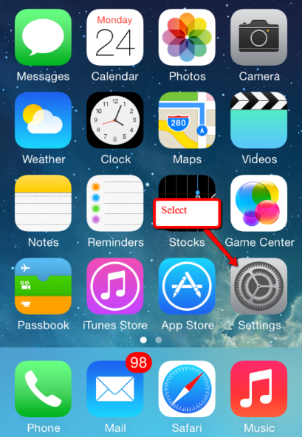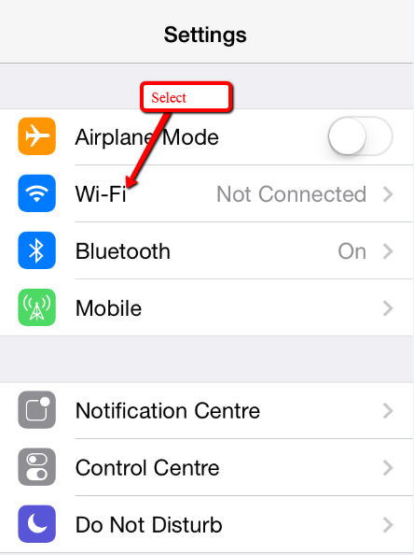

2 - In the Wi-Fi box choose FXNET Secure, when prompted enter your university username and password and select join.

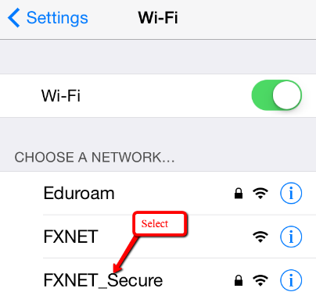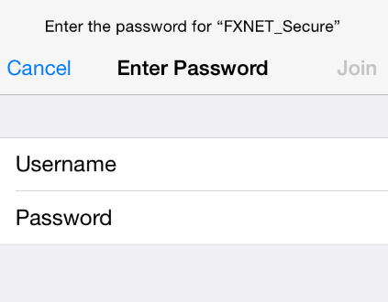

3 - Select ‘Accept’ in the certificate box and you will be connected to FXNET Secure.

