Connecting to the Resnet WI-FI

Problem:
Connecting to Resnet WI-FI

Problem Solution:
Follow the How To guide below.

How To:

Open a list of the available Wi-Fi networks on your device.
Select the Resnet network and click connect.
Open a browser on your device. You should see one of the following pages.

Example page 1
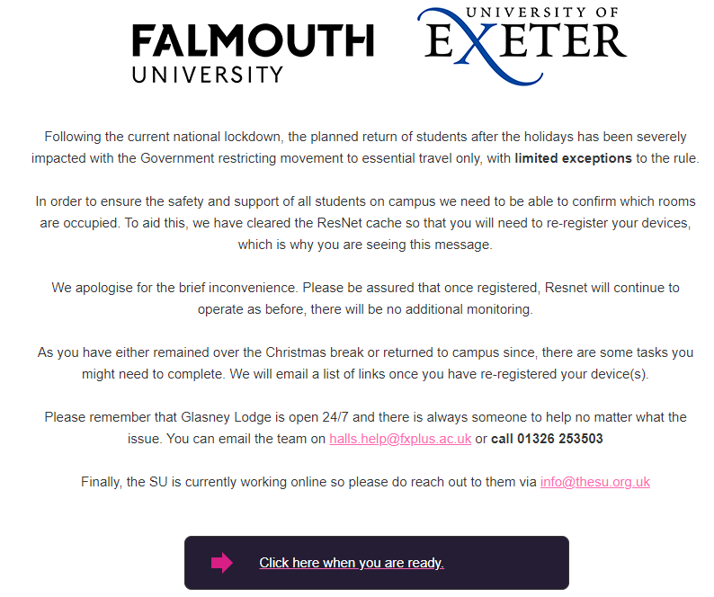

Example Page 2
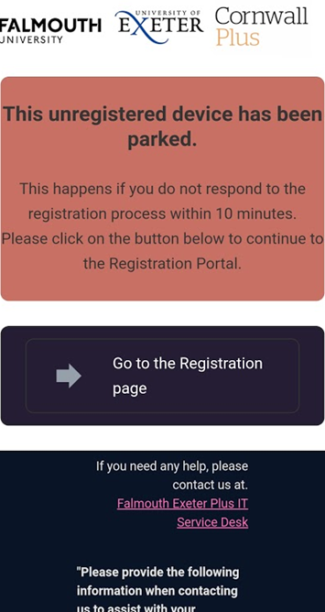

If you cannot see either of the pages above, type in and navigate to the address www.falmouth.ac.uk. This should direct you to one of the above pages.

Follow the on-screen prompts and instructions that will lead you to set up your connection to the network.

If you have any problems getting connected to the Resnet Wi-Fi, please contact the Service Desk.

