Connecting to the Guest WI-FI

Problem:
Connecting to Guest WI-FI

Problem Solution:
Follow the How To guide below.

How To:

Open a list of the available Wi-Fi networks on your device.
Select the Guest network and click connect.
Open a browser on your device. You should see one of the following pages.

Example page 1
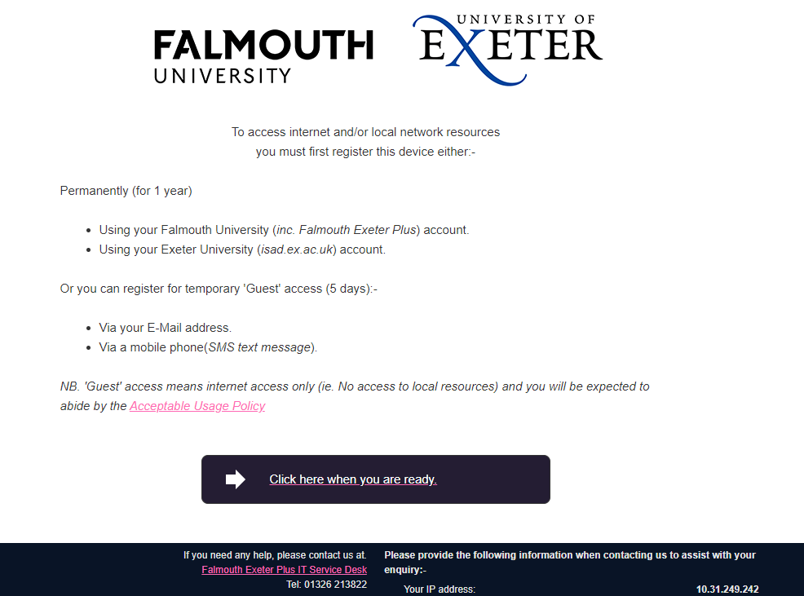

Example Page 2 Example Page 3

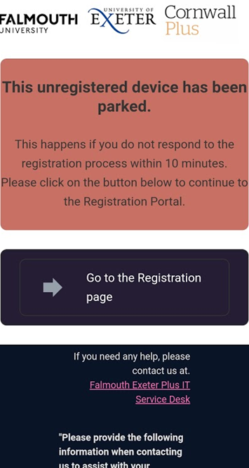
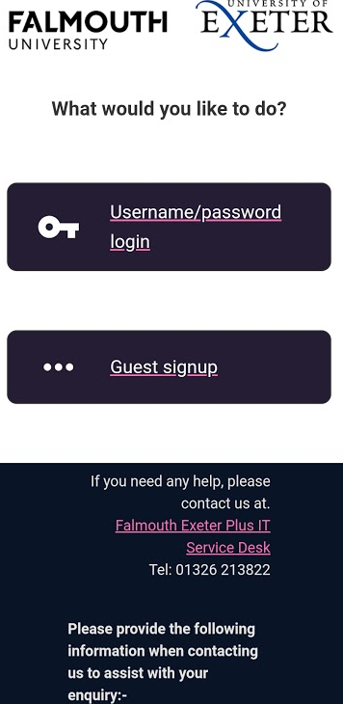

If you can not see any of the pages above, type in and navigate to the address www.falmouth.ac.uk. This should direct you to one of the above pages.

Follow the on screen prompts and instructions that will lead you to set up your connection to the network.

If you have any problems getting connected to the Guest Wi-Fi, please contact the Service Desk.

